Список карт очень большой, тема в процессе заполнения!

Тема про kfo и нестандартные игровые режимы KF.

Огромное спасибо [**DMN666**](http://forums.tripwireinteractive.com/member.php?u=51275) за помощь и позволение копи-пастить из его постов. Без него этой темы не было бы.

Если нашли ошибку или есть предложение на счет режимов\ карт - пишите в ЛС.

**Прогресс**

[spoiler]- ~~kfo~~. - ~~Toy Master~~. - ~~Glass House~~. - ~~Aliens~~. - ~~Dead Space~~. - ~~TSC~~. - ~~Trials Mod~~. - ~~Тест карты~~. - ~~Gun Game~~[/spoiler][spoiler]

~~-~~ ~~KF mod mission~~. - ~~Story карты~~ сломаны к чертям, еще раз спасибо TWI

- Doom mod / скриншоты

- Vehicle mod. - Cписок карт

- Привести все в порядок (70%)

[/spoiler]

**Заметки**

**-** Символом * будут помечаться карты где используется серый, кастомный скрипт.

**-** Символом * будут помечаться карты для которых нужен [***CustomSpawnFix***](http://forums.tripwireinteractive.com/showthread.php?t=100579)**.** Спасибо Tripwire за то, что поменяли коды мобов и поломали старые карты.

**- *ScrnStoryGame*** **/** ***KFChaingunTurret*** **/** ***Fall_TriggerPack*** **/** ***KFGasCan* / *clientmaterialtrigger*** белые мутаторы.

**-** Избегайте [***NetReduce***](http://forums.tripwireinteractive.com/showthread.php?t=100703) и подобных мутаторов. Или будут пропадать ключи, спавны оружия, рубильники, не работать скрипты.

**-** Некоторые карты из других режимов могут работать в KFO если вручную поменять акроним (***KF****-* / ***KFS****-* / ***TOY****-*).

[spoiler]

* kf-Arcade-Mission-v2
* KF-Hokuto_Ujou_Hagan_Ken_v2
* KF-LaserChallengeV3
* KF-Offices-Story-alpha1
* KF-roofhop
* KF-SaarV5
* KF-Strangev12
* KF-TheHiveV1REV3
* KF-TheHiveV2FC
* KF-TheHiveV3Beta
* TOY-DevilsDollhouse
* TOY-DevilsDollhouse-FixV3

[/spoiler]

**Killing Floor Mode**

**Заметки**

***-*** Карты старые, будьте готовы ко всяким багам.

**-** Многие из них имеют модифицированные спавны/ инвентарь. Если у вас начинает вылетать, в первую очередь пеняйте на мутаторы.

[spoiler]New Haven ~ *S281* & Fel*

KF-NewHaven-Mission-Beta4.rom

Форум - [forums.tripwireinteractive.com/showthread.php?t=73451](http://forums.tripwireinteractive.com/showthread.php?t=73451)

D/L - [mediafire.com/download/fdbfjch1omyx23m/KF-NewHaven-Mission-Beta4.zip](http://www.mediafire.com/download/fdbfjch1omyx23m/KF-NewHaven-Mission-Beta4.zip)[spoiler]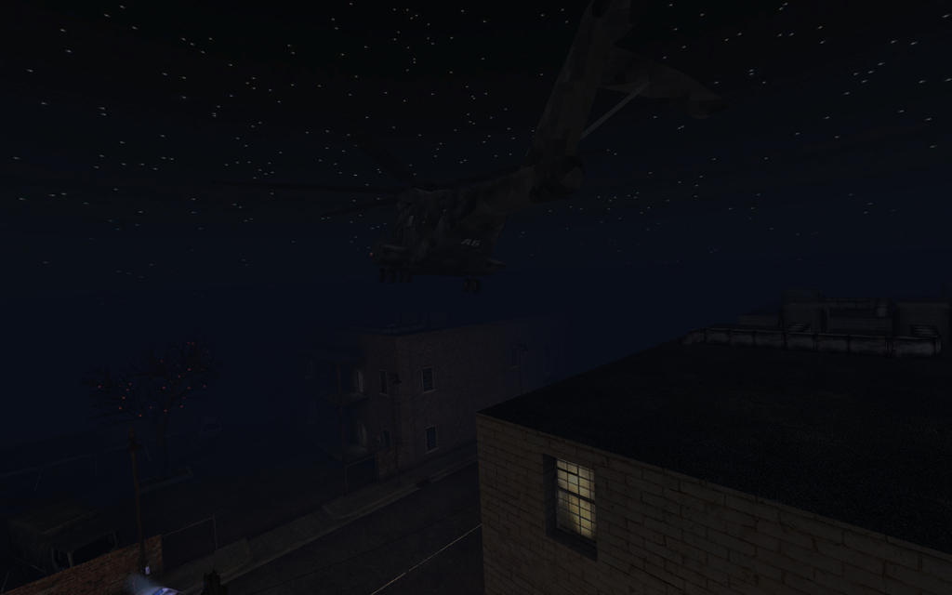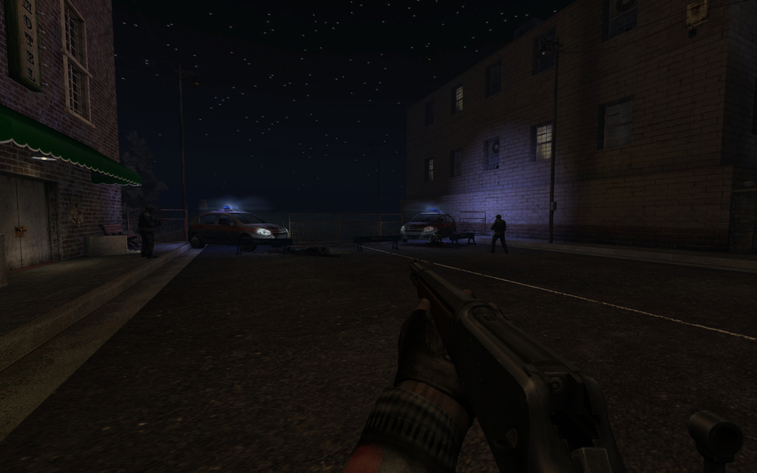[/spoiler]

Obsidian ~ *S281* & Fel*\**

KF-Obsidian-Mission.rom

Workshop - [steamcommunity.com/sharedfiles/filedetails/?id=123442638](http://steamcommunity.com/sharedfiles/filedetails/?id=123442638)

Форум - [forums.tripwireinteractive.com/showthread.php?t=50370](http://forums.tripwireinteractive.com/showthread.php?t=50370)

ModDb - [moddb.com/games/killing-floor/addons/kf-obsidian-mission-map](http://www.moddb.com/games/killing-floor/addons/kf-obsidian-mission-map)

D/L - [mediafire.com/download/fpq4cjakkhelvty/KF-Obsidian-Mission.zip](http://www.mediafire.com/download/fpq4cjakkhelvty/KF-Obsidian-Mission.zip) [spoiler]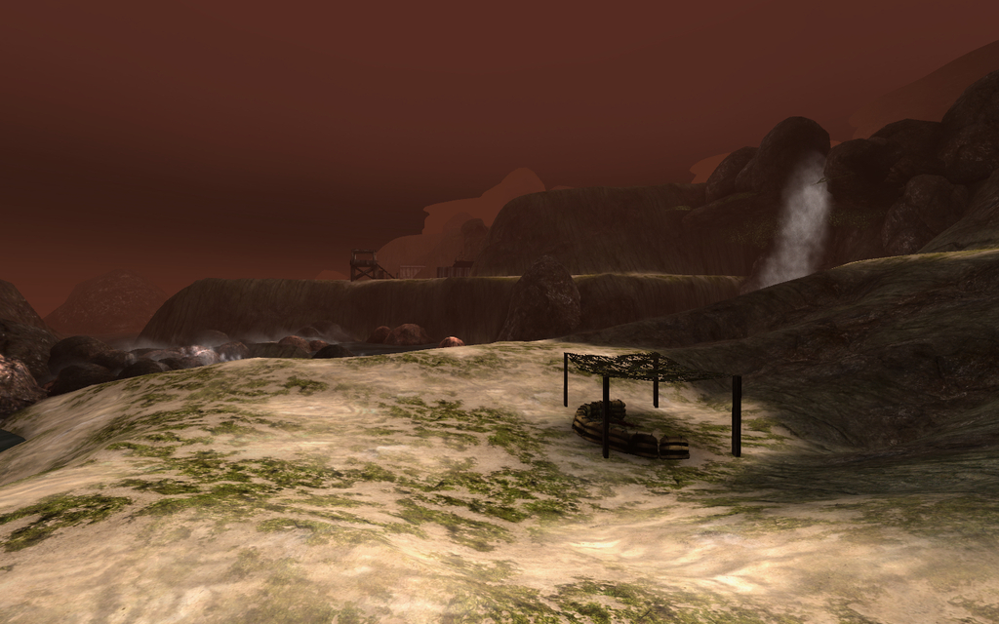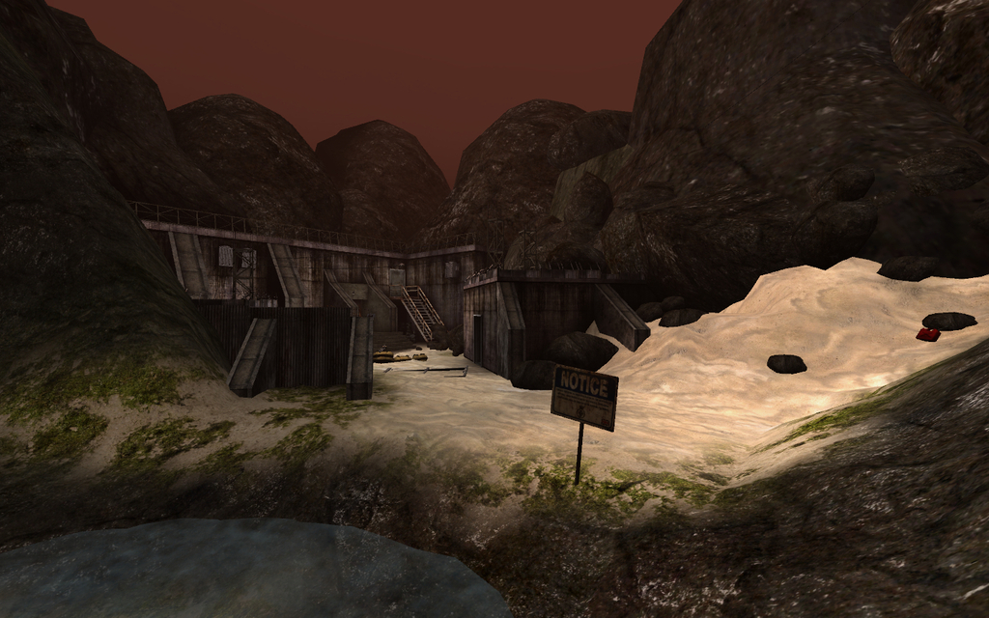[/spoiler]

Damnation ~ *Fel*

KF-Damnation-Mission-STD_Edit.rom

Workshop - [steamcommunity.com/sharedfiles/filedetails/?id=308711971](http://steamcommunity.com/sharedfiles/filedetails/?id=308711971)

Форум - [forums.tripwireinteractive.com/showthread.php?t=42083](http://forums.tripwireinteractive.com/showthread.php?t=42083)

D/L - [mediafire.com/download/1j7f5slsph12alq/KF-Damnation-Mission-STD_Edit.zip](http://www.mediafire.com/download/1j7f5slsph12alq/KF-Damnation-Mission-STD_Edit.zip) [spoiler]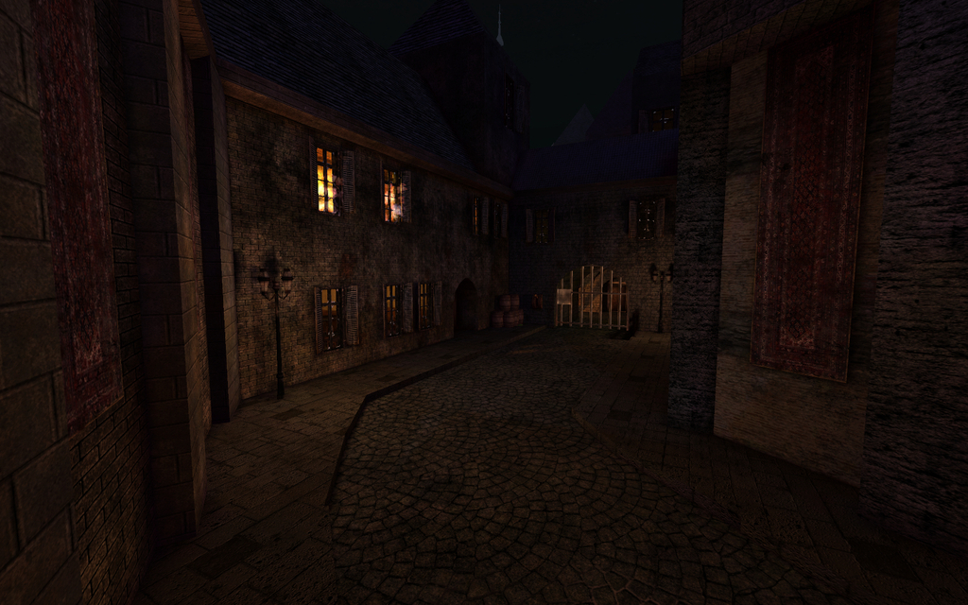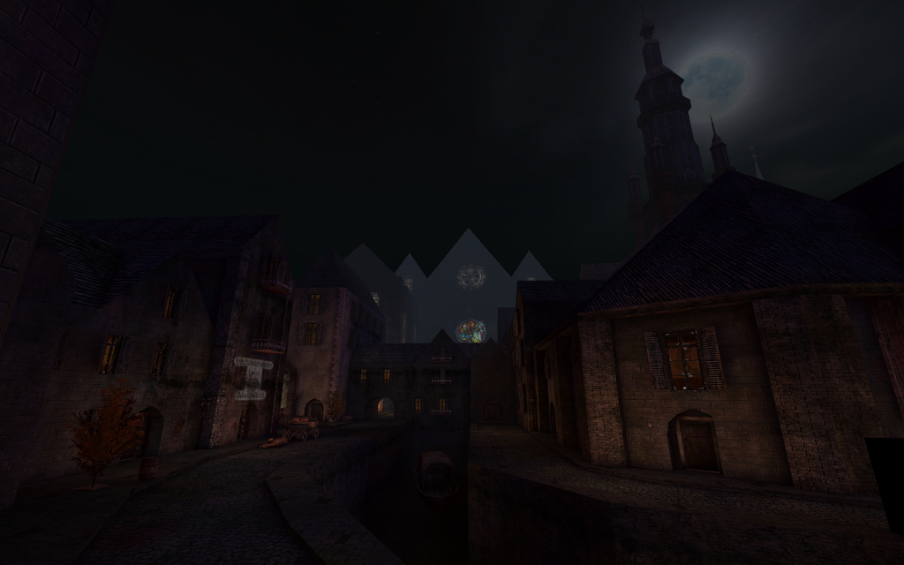[/spoiler]

Road to Perdition ~ *S281* & Fel*

KF-RoadtoPerdition-Campaign.rom

Workshop - [steamcommunity.com/sharedfiles/filedetails/?id=123545027](http://steamcommunity.com/sharedfiles/filedetails/?id=123545027)

Форум - [forums.tripwireinteractive.com/showthread.php?t=49495](http://forums.tripwireinteractive.com/showthread.php?t=49495)

ModDb - [moddb.com/games/killing-floor/addons/kf-roadtoperdition-mission-map](http://www.moddb.com/games/killing-floor/addons/kf-roadtoperdition-mission-map)

D/L - [mediafire.com/download/v3h1d9bwmr1gtwy/KF-RoadtoPerdition-Campaign.zip](http://www.mediafire.com/download/v3h1d9bwmr1gtwy/KF-RoadtoPerdition-Campaign.zip) [spoiler]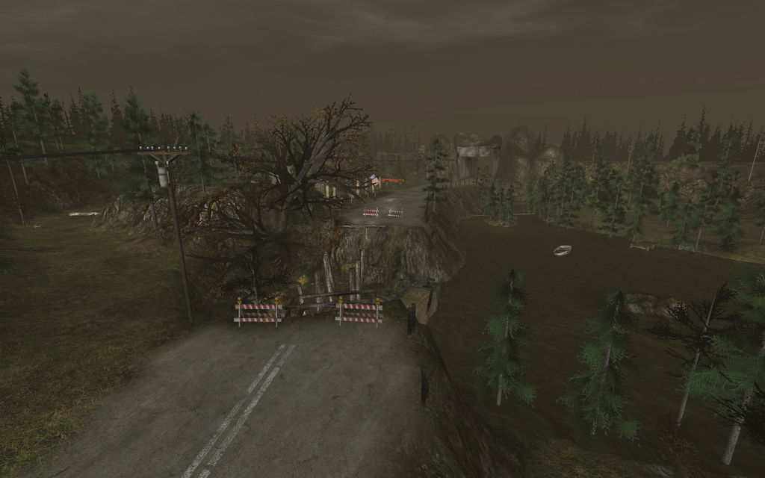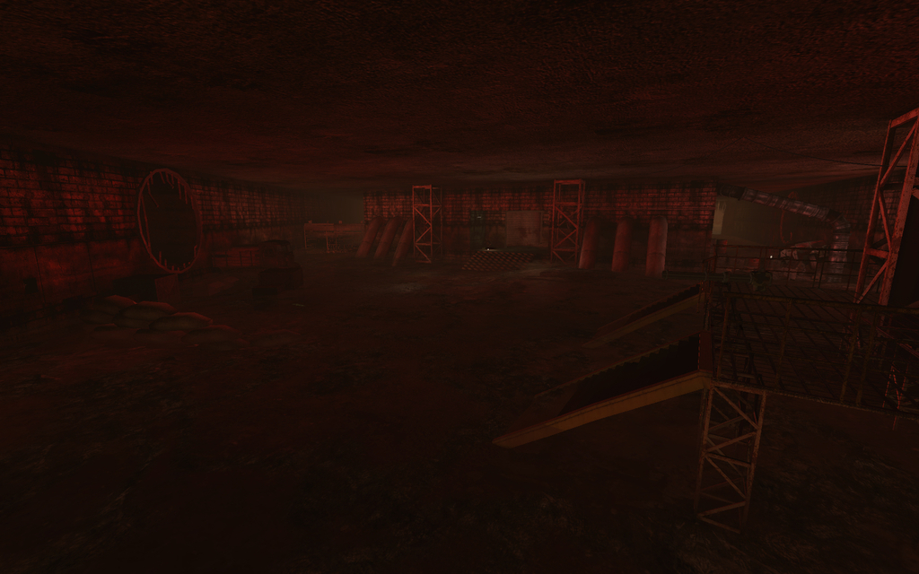[/spoiler]

Perdition ~ *S281* & Fel*

KF-Perdition-Campaign.rom

Форум - [forums.tripwireinteractive.com/showthread.php?t=46329](http://forums.tripwireinteractive.com/showthread.php?t=46329)

D/L - [mediafire.com/download/2w61ciudtxbcbe4/KF-Perdition-Campaign.zip](http://www.mediafire.com/download/2w61ciudtxbcbe4/KF-Perdition-Campaign.zip)[spoiler]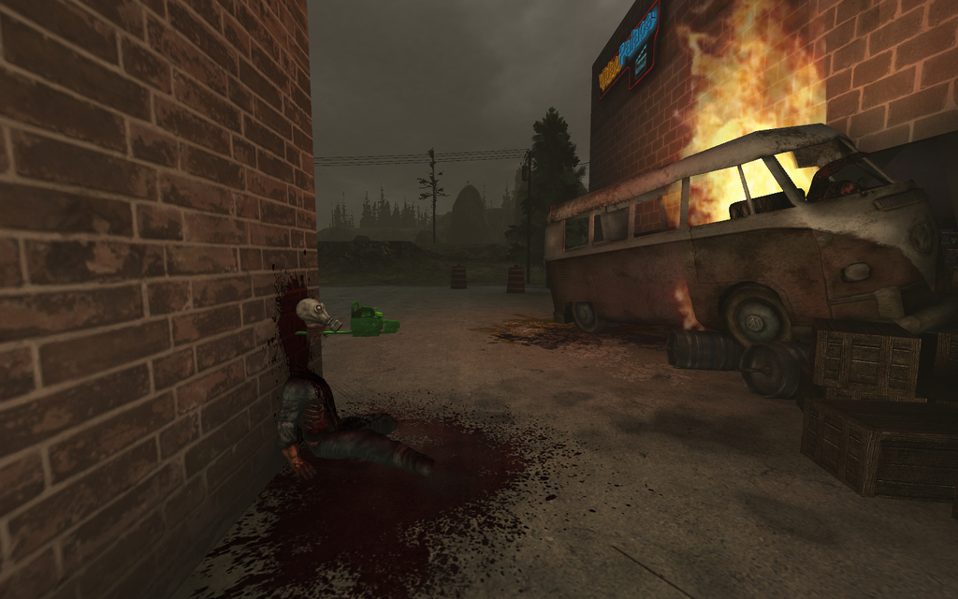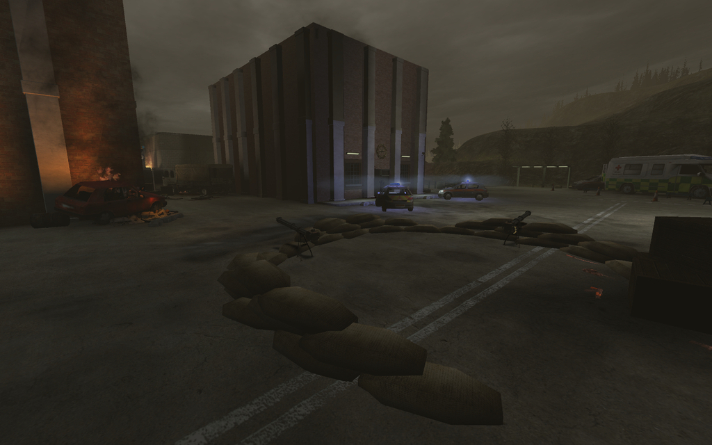[/spoiler]

Candle Smoke ~ *Fel* & Dextronaut

KF-Candlesmoke-Revamp-STD-Ed.rom

Workshop - [steamcommunity.com/sharedfiles/filedetails/?id=311116856](http://steamcommunity.com/sharedfiles/filedetails/?id=311116856)

Форум - [forums.tripwireinteractive.com/showthread.php?t=62857](http://forums.tripwireinteractive.com/showthread.php?t=62857)

D/L - [mediafire.com/download/mg3cdm8ia7p5j9d/KF-Candlesmoke-Revamp-STD-Ed.zip](http://www.mediafire.com/download/mg3cdm8ia7p5j9d/KF-Candlesmoke-Revamp-STD-Ed.zip)[spoiler]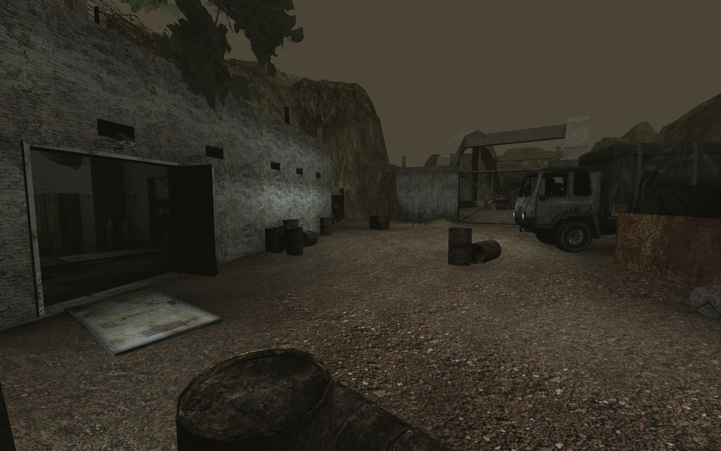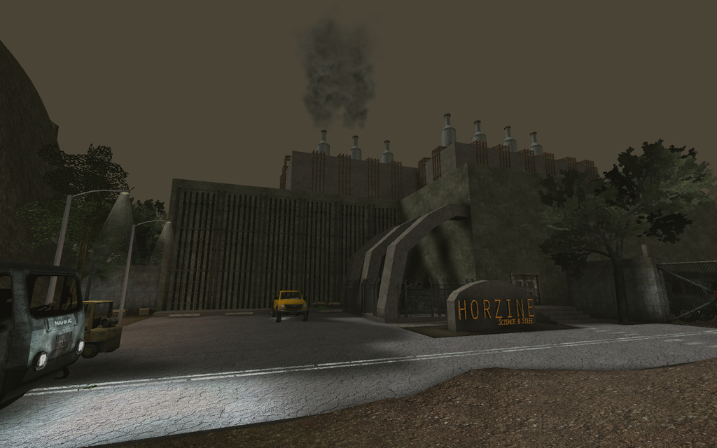[/spoiler]

OldeTower v3 ~ *PiX*

KF-OldeTower-beta3.rom

Workshop - [steamcommunity.com/sharedfiles/filedetails/?id=263729647](http://steamcommunity.com/sharedfiles/filedetails/?id=263729647)

Форум - [forums.tripwireinteractive.com/showthread.php?t=46706](http://forums.tripwireinteractive.com/showthread.php?t=46706)

ModDb - [moddb.com/games/killing-floor/addons/kf-oldetower-beta3](http://www.moddb.com/games/killing-floor/addons/kf-oldetower-beta3)

D/L - [mediafire.com/download/5sitxn0nmwf4ca3/KF-OldeTower-beta3.zip](http://www.mediafire.com/download/5sitxn0nmwf4ca3/KF-OldeTower-beta3.zip) [spoiler]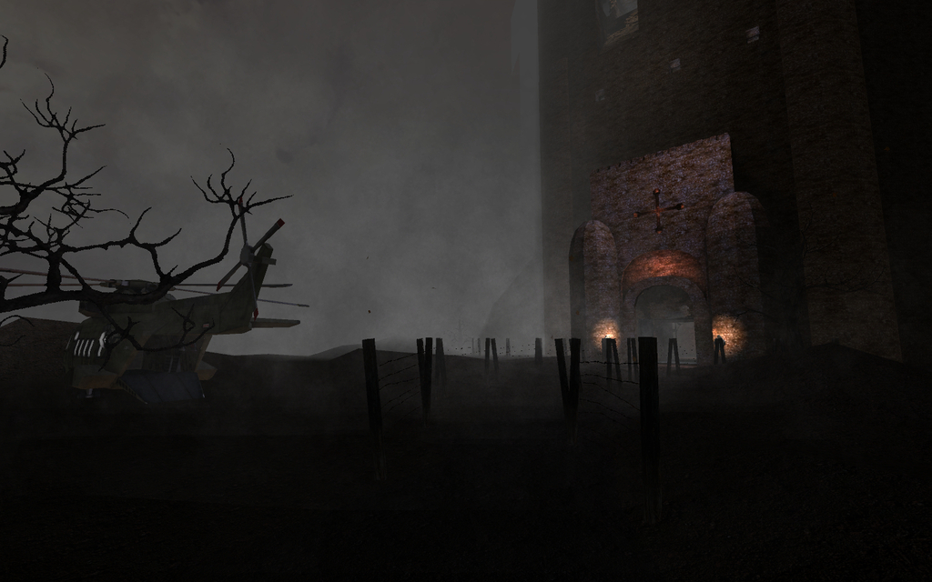[/spoiler]

Story Map in 24h ~ *PiX*

KF-StoryMapIn24h-FIX2.rom

Форум - [forums.tripwireinteractive.com/showthread.php?t=52493](http://forums.tripwireinteractive.com/showthread.php?t=52493)

D/L - [mediafire.com/download/ab1asbjlpgcmrz3/KF-StoryMapIn24h-FIX2.zip](http://www.mediafire.com/download/ab1asbjlpgcmrz3/KF-StoryMapIn24h-FIX2.zip)[spoiler]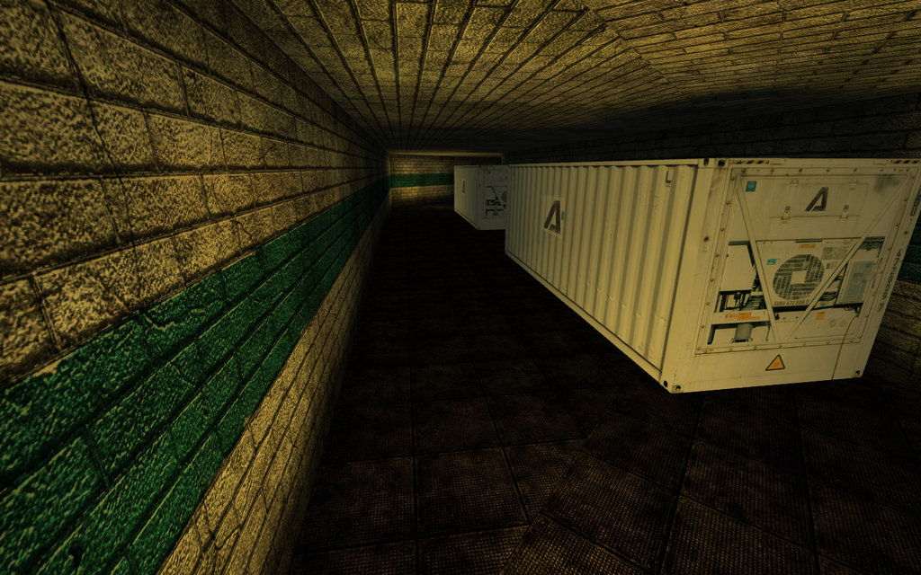[/spoiler]

Office Story ~ *PiX\**

KF-Offices-Story-alpha1.rom

Форум - [forums.tripwireinteractive.com/showthread.php?t=51320](http://forums.tripwireinteractive.com/showthread.php?t=51320)

D/L - [mediafire.com/download/egafy649ks7xvuo/KF-Offices-Story-alpha1.zip](http://www.mediafire.com/download/egafy649ks7xvuo/KF-Offices-Story-alpha1.zip)[spoiler]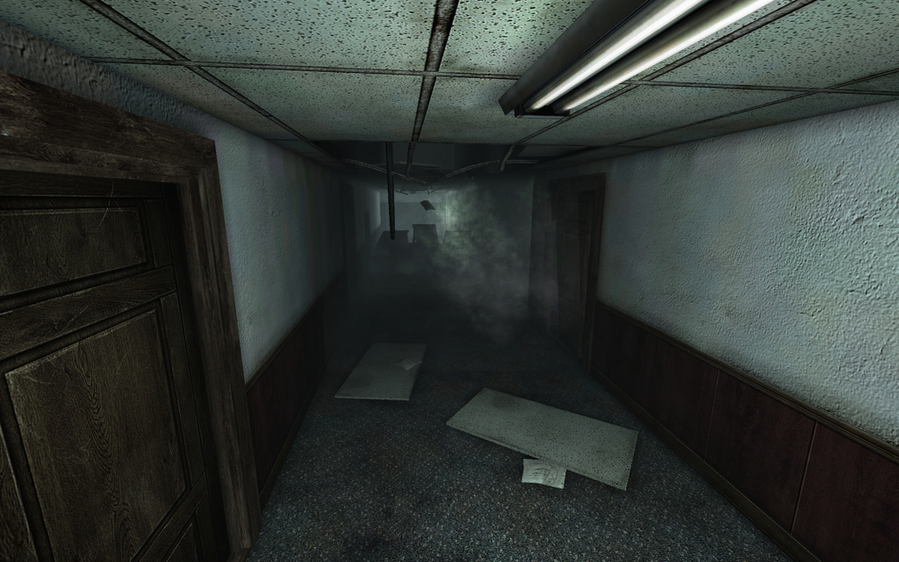[/spoiler]

Commish Farm ~ *PiX*

KF-COM-Farm-beta1b.rom

Форум - [forums.tripwireinteractive.com/showthread.php?t=85898](http://forums.tripwireinteractive.com/showthread.php?t=85898)

D/L - [mediafire.com/download/w2vj0hvvy9niu62/KF-COM-Farm-beta1b.zip](http://www.mediafire.com/download/w2vj0hvvy9niu62/KF-COM-Farm-beta1b.zip)[spoiler]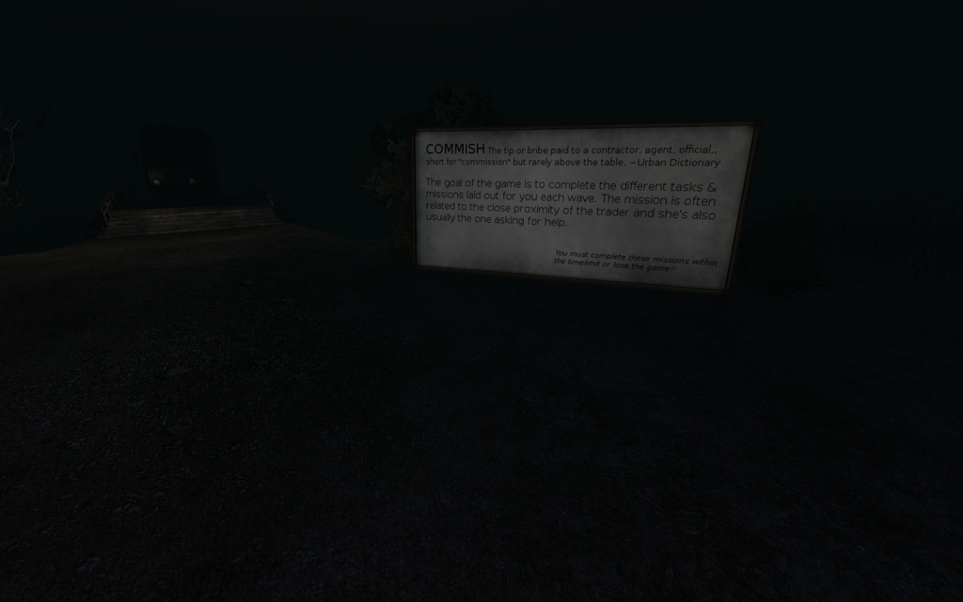[/spoiler]

The Hive v1 ~ *KiCk3R\**

KF-TheHiveV1REV3.rom

Workshop - [steamcommunity.com/sharedfiles/filedetails/?id=98702458](http://steamcommunity.com/sharedfiles/filedetails/?id=98702458)

Форум - [forums.tripwireinteractive.com/showthread.php?t=30029](http://forums.tripwireinteractive.com/showthread.php?t=30029)

D/L - [mediafire.com/download/54226a82spjh7d5/KF-TheHiveV1REV3.zip](http://www.mediafire.com/download/54226a82spjh7d5/KF-TheHiveV1REV3.zip)[spoiler]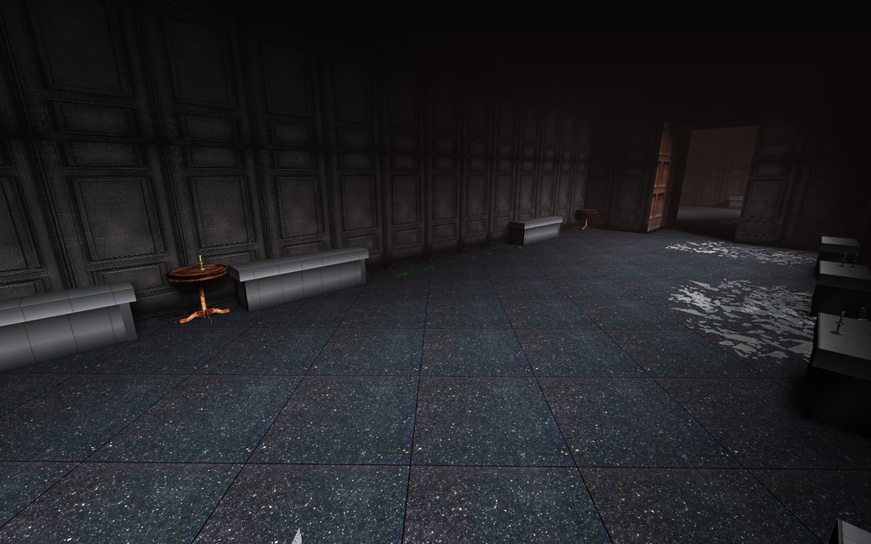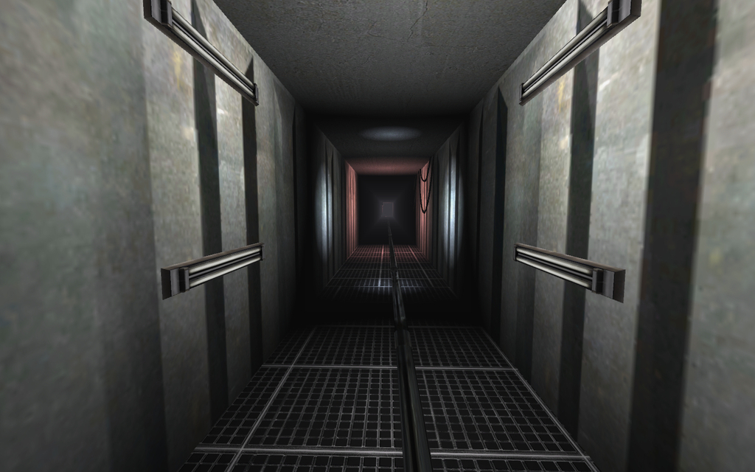[/spoiler]

The Hive v2 ~ *KiCk3R\**

KF-TheHiveV2FC.rom

Форум - [forums.tripwireinteractive.com/showthread.php?t=35402](http://forums.tripwireinteractive.com/showthread.php?t=35402)

ModDb - [moddb.com/games/killing-floor/addons/kf-hivev2fc](http://www.moddb.com/games/killing-floor/addons/kf-hivev2fc)

D/L - [mediafire.com/download/k43n1ivpv3d3c47/KF-TheHiveV2FC.zip](http://www.mediafire.com/download/k43n1ivpv3d3c47/KF-TheHiveV2FC.zip)[spoiler]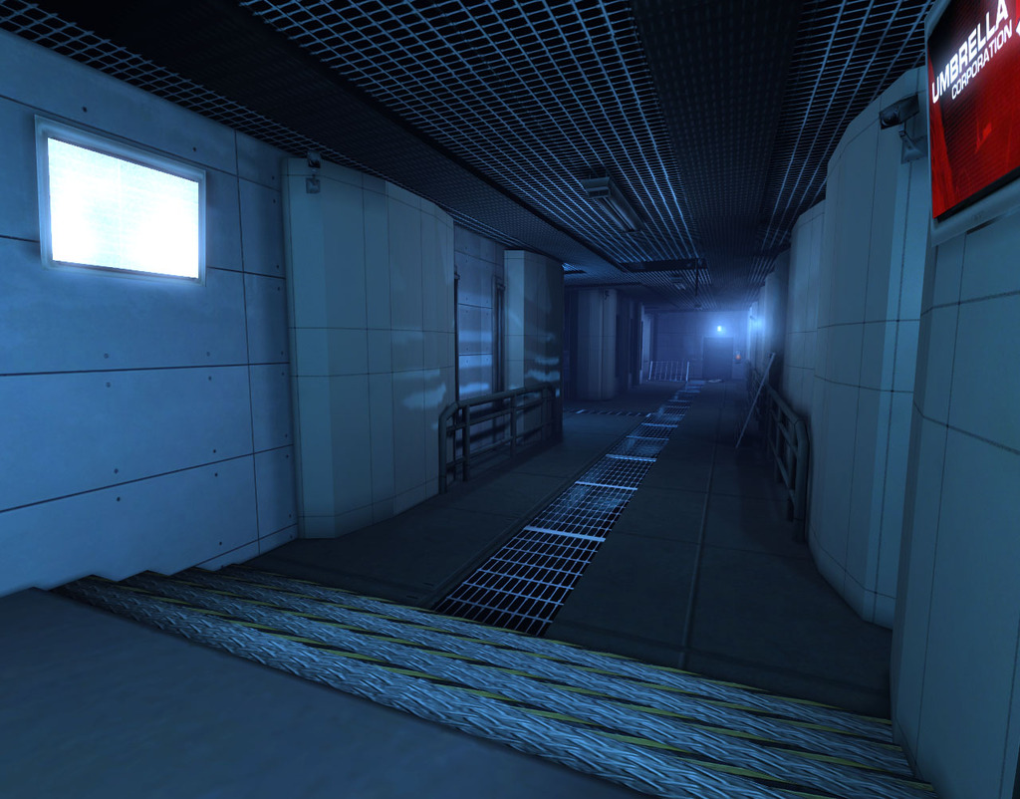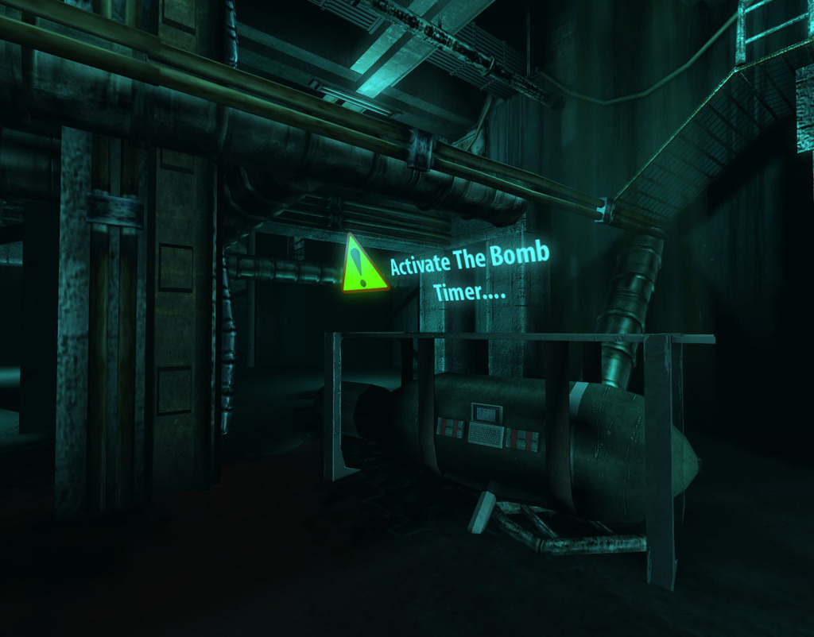[/spoiler]

The Hive v3 ~ *KiCk3R\**

KF-TheHiveV3Beta.rom

Workshop - [steamcommunity.com/sharedfiles/filedetails/?id=123976031](http://steamcommunity.com/sharedfiles/filedetails/?id=123976031)

Форум - [forums.tripwireinteractive.com/showthread.php?t=44007](http://forums.tripwireinteractive.com/showthread.php?t=44007)

D/L - [mediafire.com/download/u2vttt76ok0ranb/KF-TheHiveV3Beta.zip](http://www.mediafire.com/download/u2vttt76ok0ranb/KF-TheHiveV3Beta.zip)[spoiler]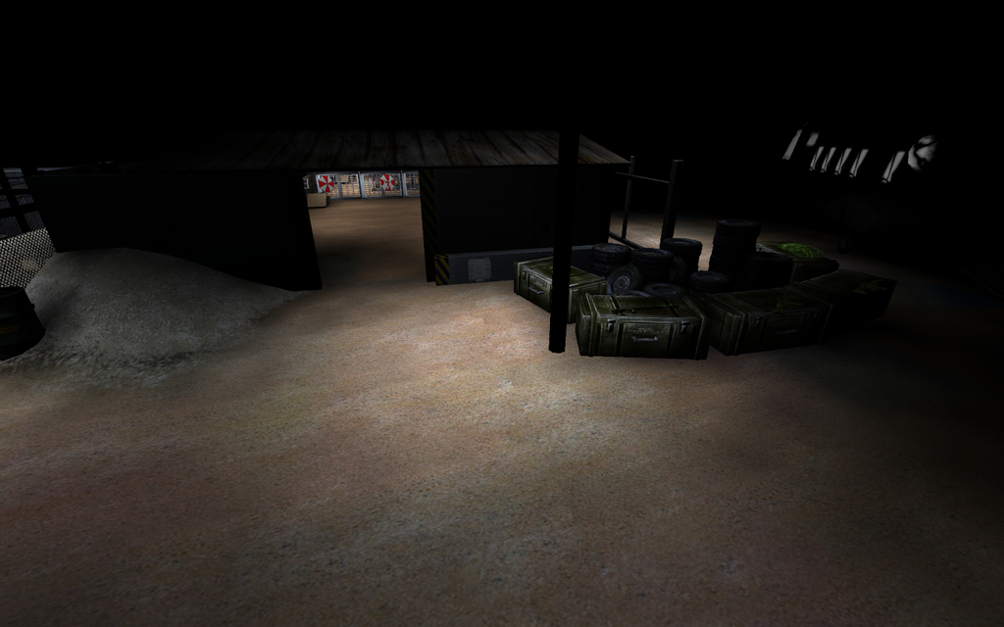[/spoiler]

Raccoon International Airport ~ *KiCk3R\**

KF-RaccoonInternationalAirportMP.rom

Workshop - [steamcommunity.com/sharedfiles/filedetails/?id=98225770](http://steamcommunity.com/sharedfiles/filedetails/?id=98225770)

ModDb - [moddb.com/games/killing-floor/addons/kf-raccoonairportmp](http://www.moddb.com/games/killing-floor/addons/kf-raccoonairportmp)

D/L - [mediafire.com/download/piyziqq74mximu4/KF-RaccoonInternationalAirportMP.zip](http://www.mediafire.com/download/piyziqq74mximu4/KF-RaccoonInternationalAirportMP.zip)[spoiler]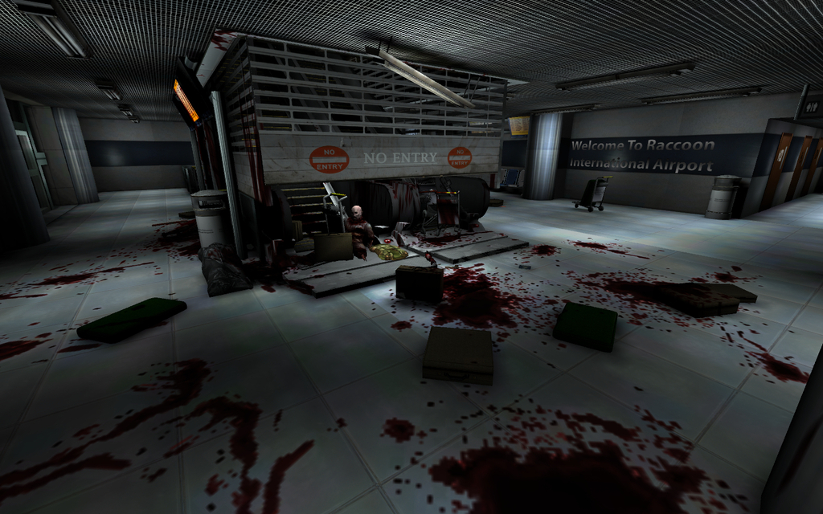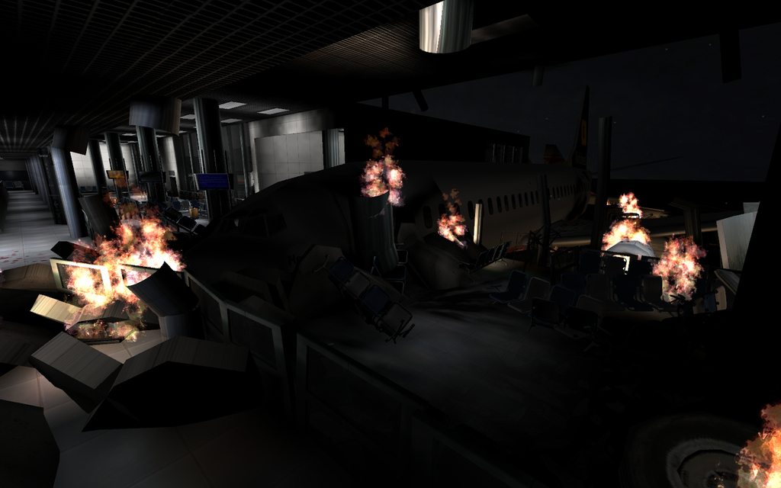[/spoiler]

Laser Challenge ~ *KiCk3R*

KF-LaserChallengeV3.rom

Workshop - [steamcommunity.com/sharedfiles/filedetails/?id=98707543](http://steamcommunity.com/sharedfiles/filedetails/?id=98707543)

D/L - [mediafire.com/download/n5xr2v4h3nqlpfk/KF-LaserChallengeV3.zip](http://www.mediafire.com/download/n5xr2v4h3nqlpfk/KF-LaserChallengeV3.zip)[spoiler]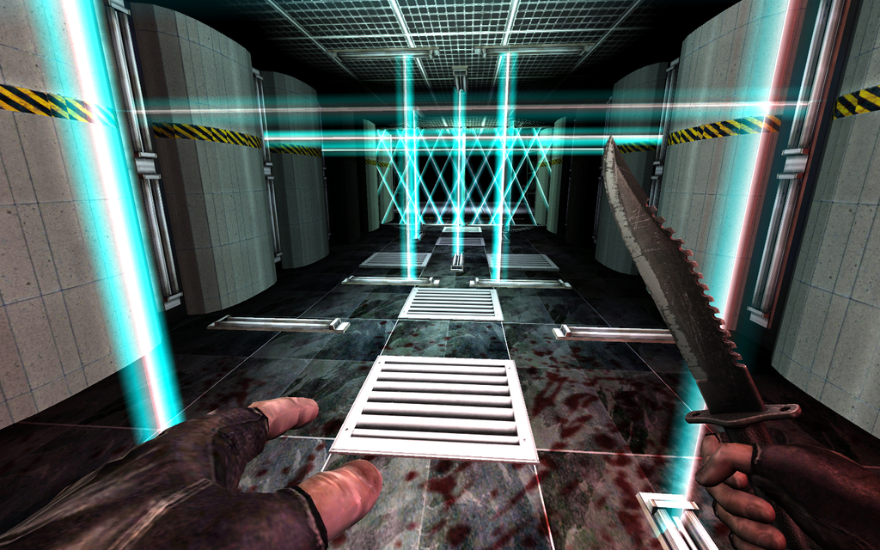[/spoiler]

Pride Hill Shopping Center ~ *KiCk3R*

KF-PrideHillV4.rom

Workshop - [steamcommunity.com/sharedfiles/filedetails/?id=98164398](http://steamcommunity.com/sharedfiles/filedetails/?id=98164398)

D/L - [mediafire.com/download/iipviekaq1z4y06/KF-PrideHillV4.zip](http://www.mediafire.com/download/iipviekaq1z4y06/KF-PrideHillV4.zip)[spoiler]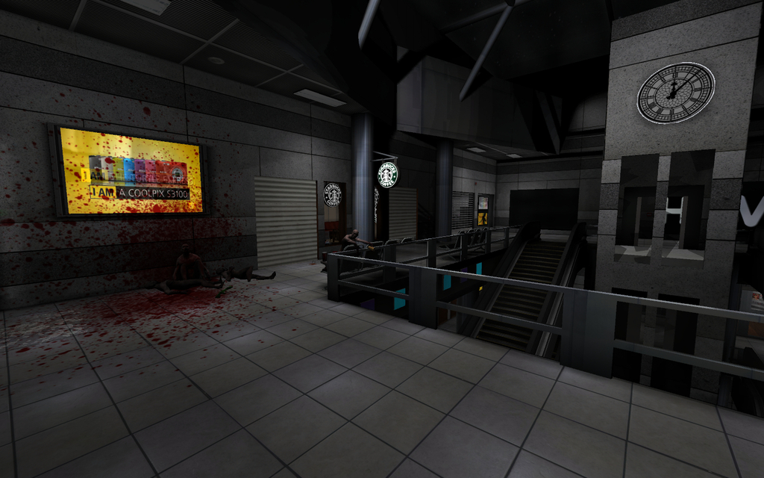[/spoiler]

Horzine Bunker ~ *Sugarfree\**

KF-MIS-Horzinebunker_B5.rom

Форум - [forums.tripwireinteractive.com/showthread.php?t=49903](http://forums.tripwireinteractive.com/showthread.php?t=49903)

D/L - [mediafire.com/download/vhiiurfefy1ihwh/KF-MIS-Horzinebunker_B5.zip](http://www.mediafire.com/download/vhiiurfefy1ihwh/KF-MIS-Horzinebunker_B5.zip)[spoiler]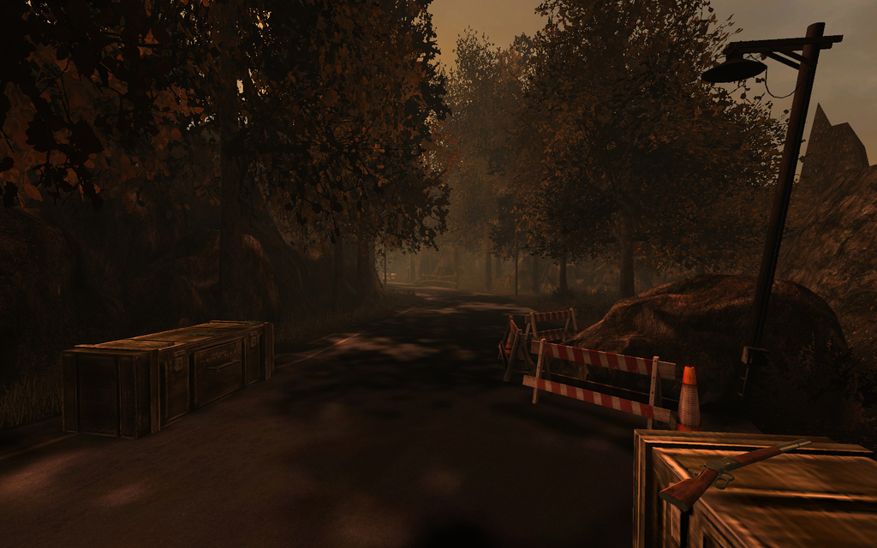[/spoiler]

Opposition ~ *patrikstar*

Kf-Opposition.rom

Форум - [killingfloor.ru/forum/index.php?/topic/3903-kf-opposition/](http://killingfloor.ru/forum/index.php?/topic/3903-kf-opposition/)

D/L - [mediafire.com/download/h4esb74z7qnt3pw/Kf-Opposition.zip](http://www.mediafire.com/download/h4esb74z7qnt3pw/Kf-Opposition.zip) [spoiler]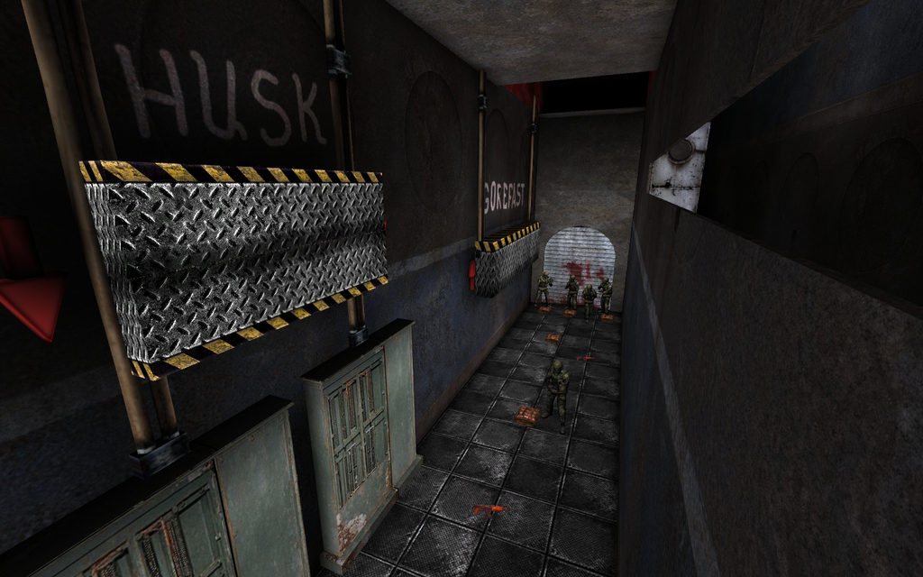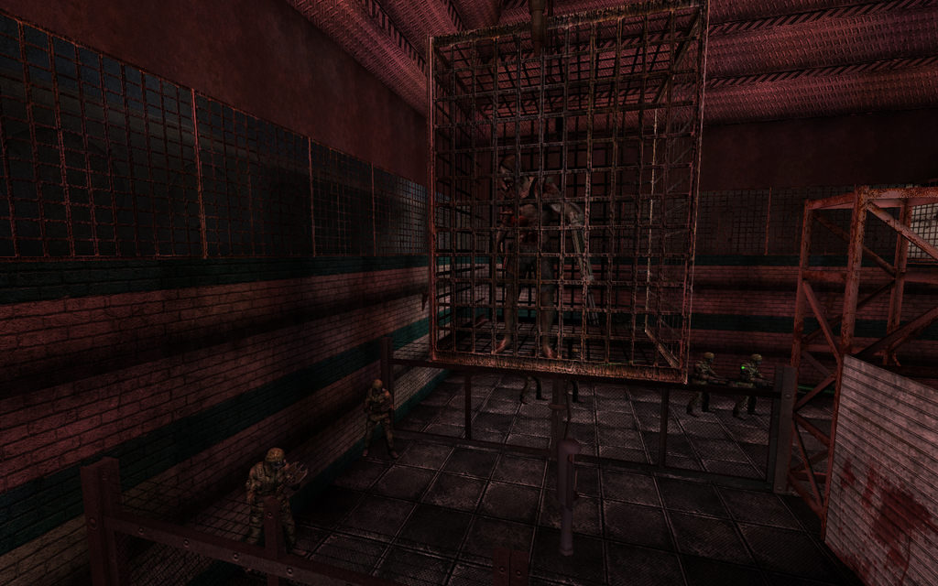[/spoiler]

Oil Platform ~ *patrikstar*

KF-Oil_platform.rom

Форум - [killingfloor.ru/forum/index.php?/topic/4032-oil-platform/](http://killingfloor.ru/forum/index.php?/topic/4032-oil-platform/)

D/L - [mediafire.com/download/oy41ucie8szclct/KF-Oil_platform.zip](http://www.mediafire.com/download/oy41ucie8szclct/KF-Oil_platform.zip) [spoiler]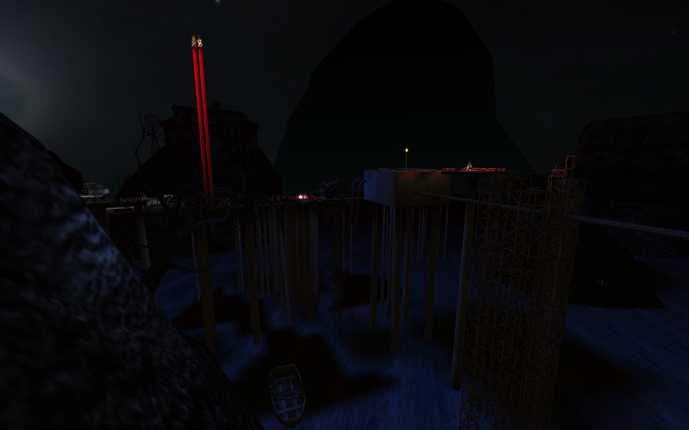[/spoiler]

Port ~ *patrikstar*

kf-PORT.rom

Форум - [killingfloor.ru/forum/index.php?/topic/4039-port/](http://killingfloor.ru/forum/index.php?/topic/4039-port/)

D/L - [mediafire.com/download/xtdz844n3rsl3jv/kf-PORT.zip](http://www.mediafire.com/download/xtdz844n3rsl3jv/kf-PORT.zip)[spoiler]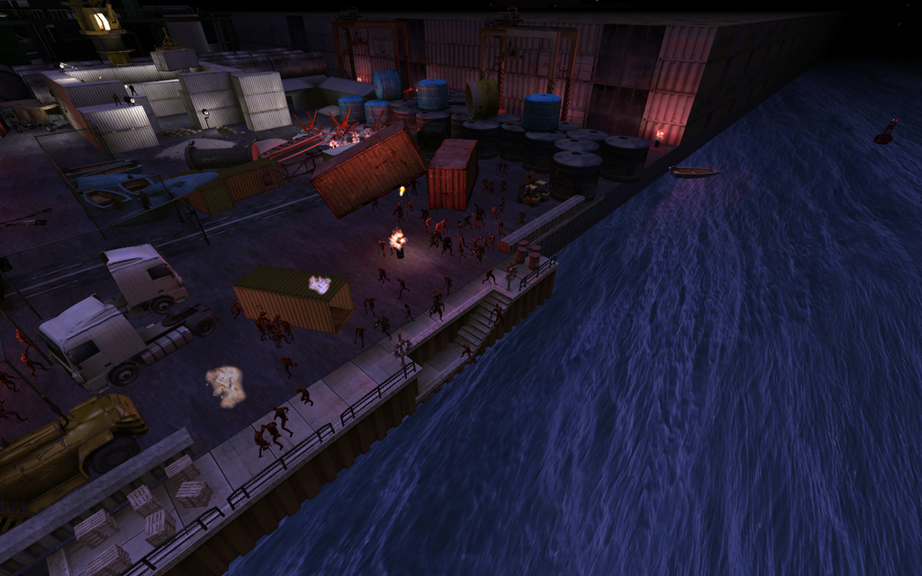[/spoiler]

Saar v7 ~ *Leon75\**

KF-SaarV7.rom

Форум - [forums.tripwireinteractive.com/showthread.php?t=38802](http://forums.tripwireinteractive.com/showthread.php?t=38802)

D/L - [mediafire.com/download/ryc0g96bqwhh3if/KF-SaarV7.zip](http://www.mediafire.com/download/ryc0g96bqwhh3if/KF-SaarV7.zip) [spoiler]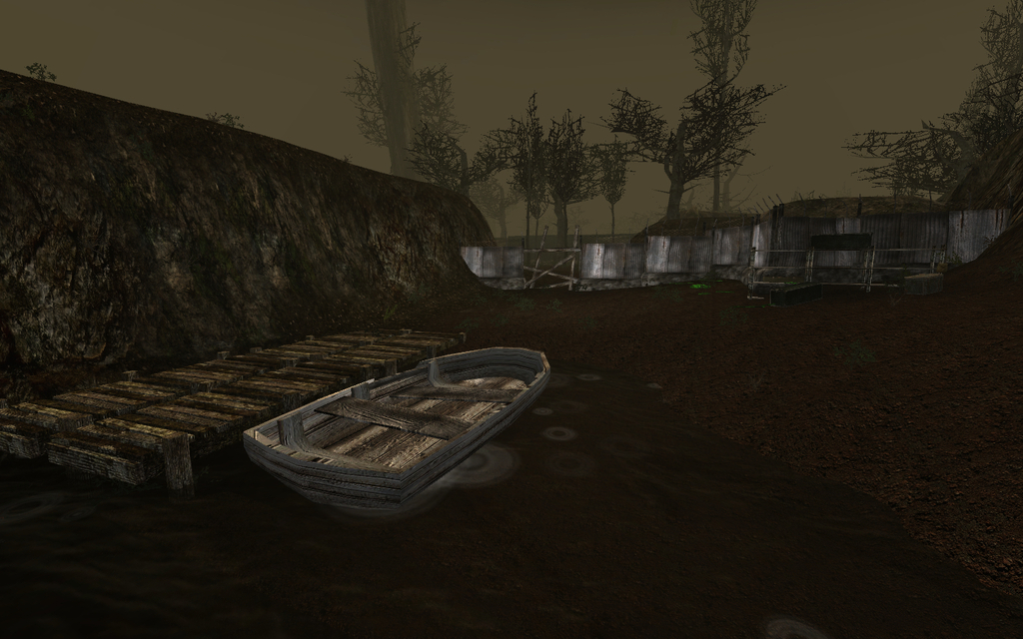[/spoiler]

Arcade Mission ~ *kingshinobi\*\**

kf-Arcade-Mission-v2.rom

Форум - [forums.tripwireinteractive.com/showthread.php?t=43319&page=3](http://forums.tripwireinteractive.com/showthread.php?t=43319&page=3)

ModDb - [moddb.com/games/killing-floor/addons/kf-arcade-mission-v2](http://www.moddb.com/games/killing-floor/addons/kf-arcade-mission-v2)

D/L - [mediafire.com/download/3cuj29dnue72hhu/kf-Arcade-Mission-v2.zip](http://www.mediafire.com/download/3cuj29dnue72hhu/kf-Arcade-Mission-v2.zip)[spoiler]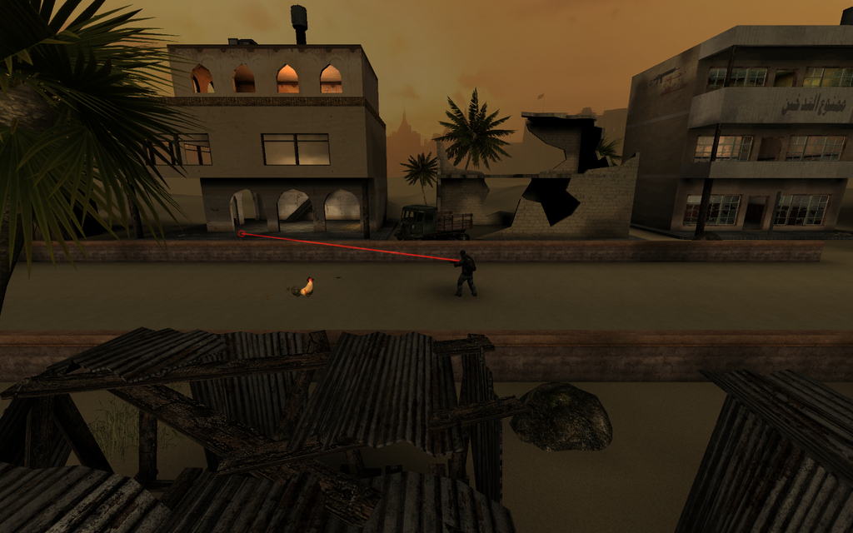[/spoiler]

Roof Hop ~ *Ninjakitty\**

KF-roofhop.rom

Форум - [forums.tripwireinteractive.com/showthread.php?t=33747](http://forums.tripwireinteractive.com/showthread.php?t=33747)

D/L - [mediafire.com/download/iqu02bcv2loujeg/KF-roofhop.zip](http://www.mediafire.com/download/iqu02bcv2loujeg/KF-roofhop.zip)[spoiler]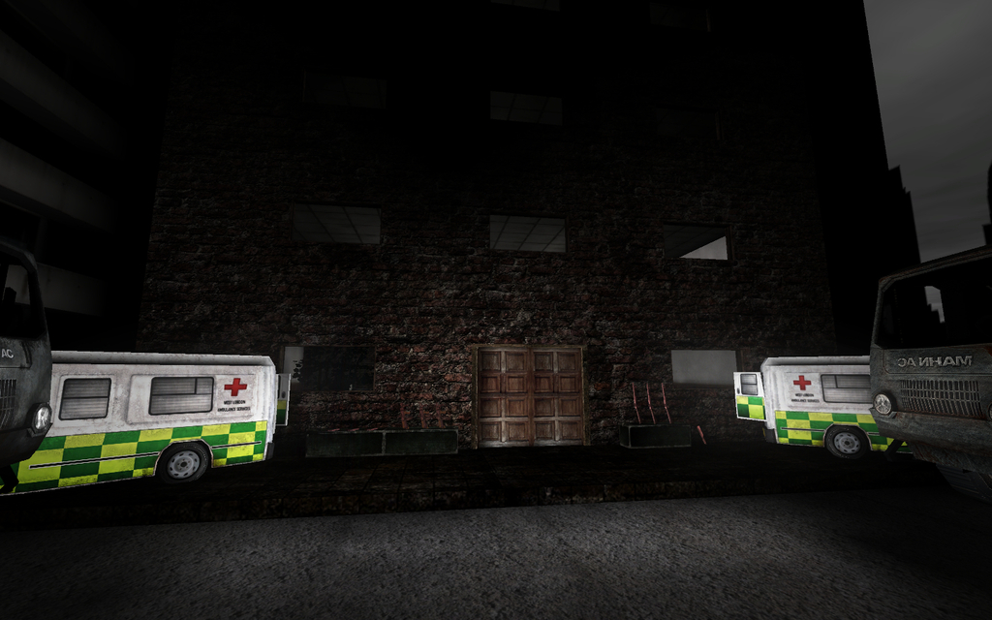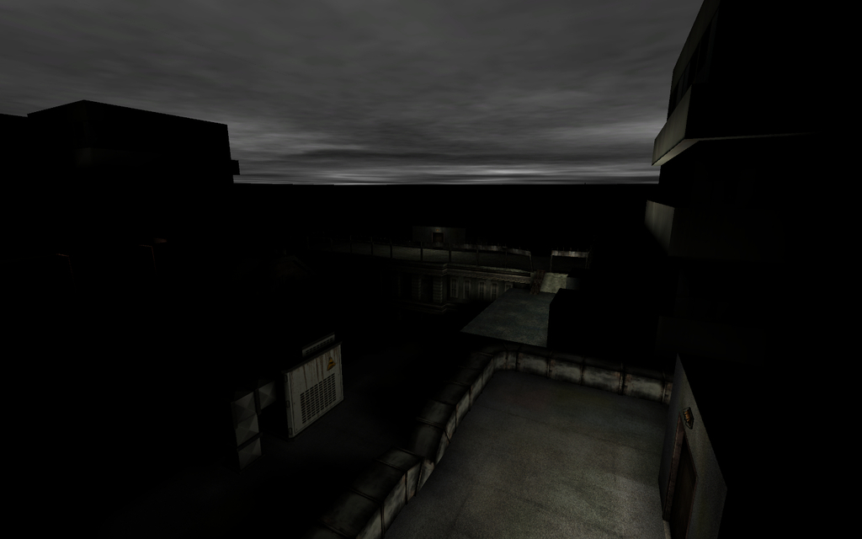[/spoiler]

Fun Fair ~ *-MGS- Sniper*

KF-SnipersFunFair.rom

Workshop - [steamcommunity.com/sharedfiles/filedetails/?id=119705373](http://steamcommunity.com/sharedfiles/filedetails/?id=119705373)

Форум - [forums.tripwireinteractive.com/showthread.php?t=86959](http://forums.tripwireinteractive.com/showthread.php?t=86959)

D/L - [mediafire.com/download/ik1635hjshzjt8j/KF-SnipersFunFair.zip](http://www.mediafire.com/download/ik1635hjshzjt8j/KF-SnipersFunFair.zip)[spoiler]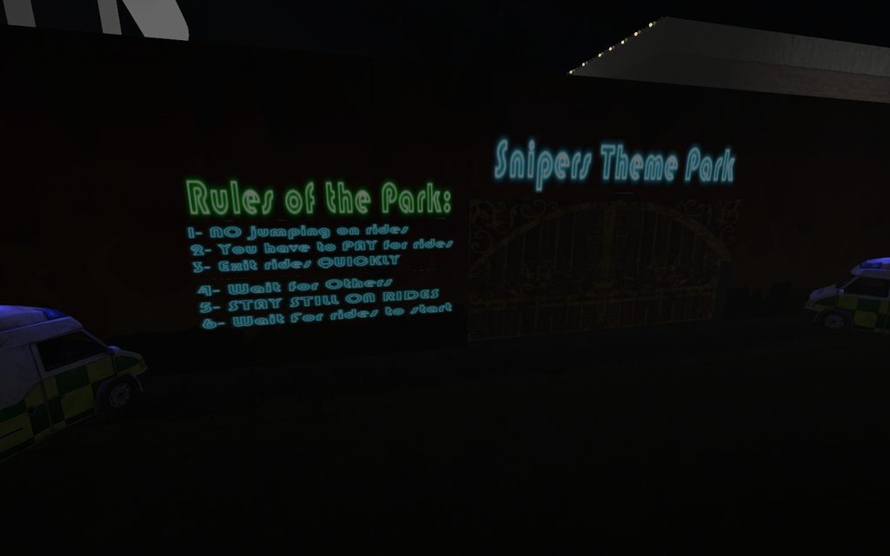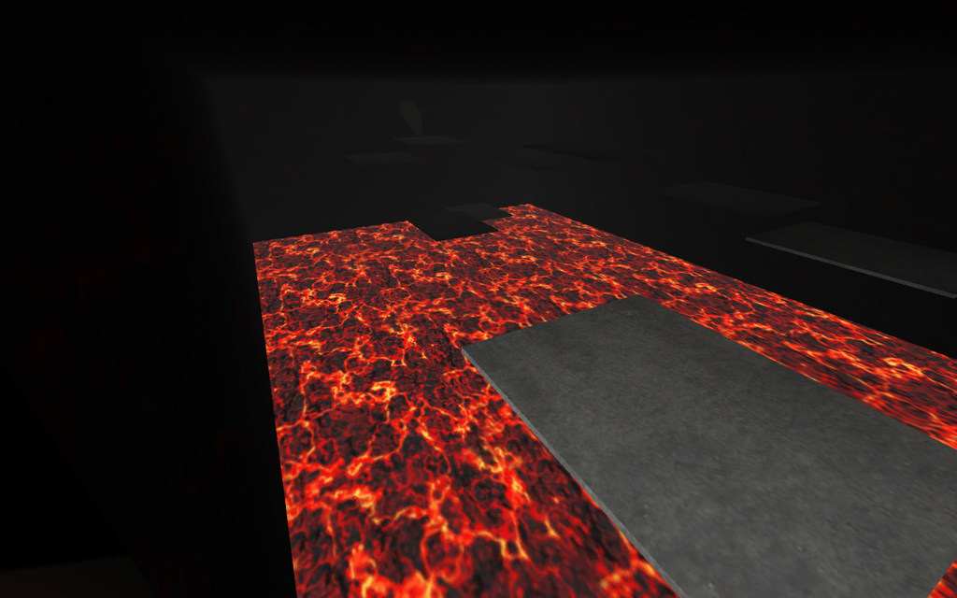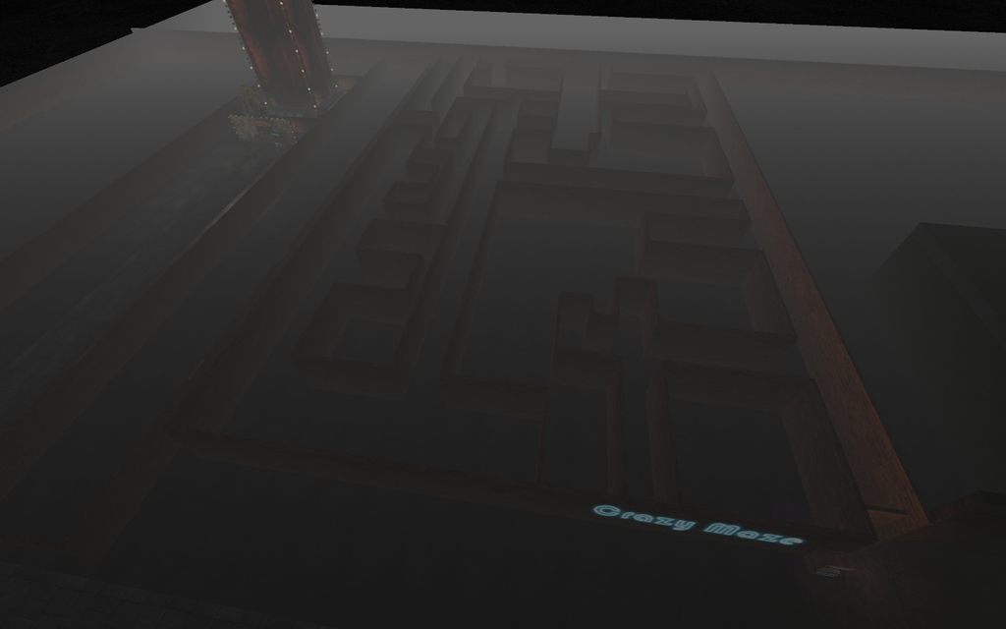[/spoiler]

Dosh or Alive ~ *oiruka101*

KF-Doshoralive2b.rom

Workshop - [steamcommunity.com/sharedfiles/filedetails/?id=159252881](http://steamcommunity.com/sharedfiles/filedetails/?id=159252881)

D/L - [mediafire.com/download/i0tmrn4hdl00959/KF-Doshoralive2b.zip](http://www.mediafire.com/download/i0tmrn4hdl00959/KF-Doshoralive2b.zip) [spoiler]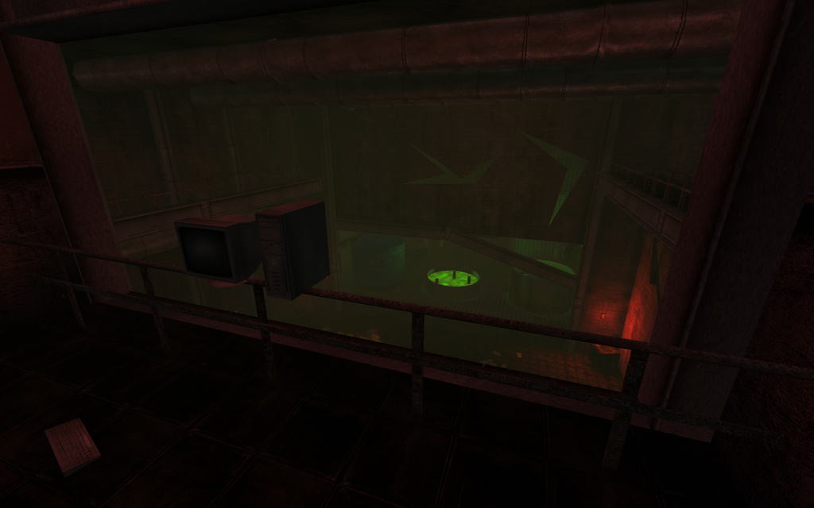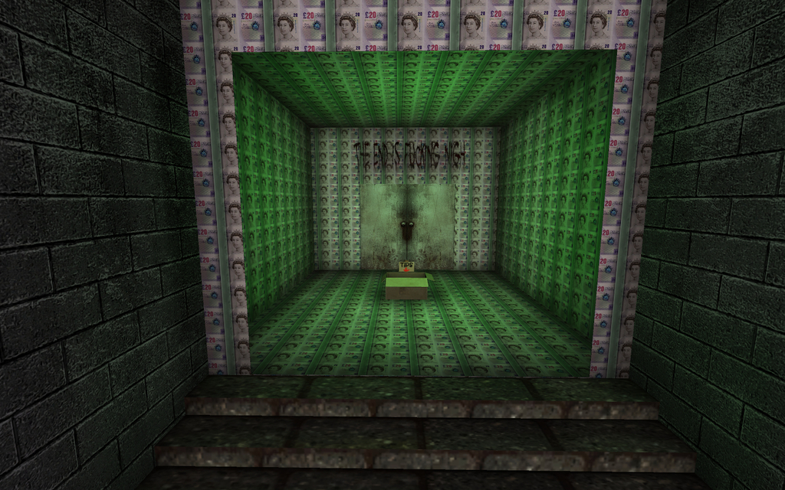[/spoiler]

Dynamic Maze ~ *Marco\**

KF-DynamicMaze.rom

Workshop - [steamcommunity.com/sharedfiles/filedetails/?id=127779171](http://steamcommunity.com/sharedfiles/filedetails/?id=127779171)

D/L - [mediafire.com/download/8w5dant7c81b2nm/KF-DynamicMaze.zip](http://www.mediafire.com/download/8w5dant7c81b2nm/KF-DynamicMaze.zip)[spoiler]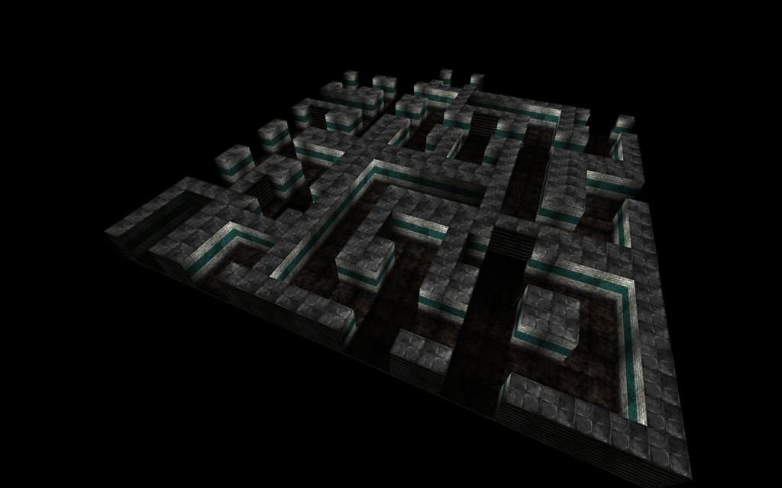[/spoiler]

Tower Defender ~ *Drunken Wolfer*

KF-TowerDefender(Beta3).rom

Форум - [forums.tripwireinteractive.com/showthread.php?t=78184](http://forums.tripwireinteractive.com/showthread.php?t=78184)

D/L - [mediafire.com/download/pqiwx4ih9qvvfp5/KF-TowerDefender(Beta3).zip](http://www.mediafire.com/download/pqiwx4ih9qvvfp5/KF-TowerDefender%28Beta3%29.zip)[spoiler][/spoiler]

Defend The Towers ~ *Lethalvortex*

kf-towerdefenderv3.rom

Workshop - [steamcommunity.com/sharedfiles/filedetails/?id=112942560](http://steamcommunity.com/sharedfiles/filedetails/?id=112942560)

D/L - [mediafire.com/download/6c32tcz8wcedctv/kf-towerdefenderv3.zip](http://www.mediafire.com/download/6c32tcz8wcedctv/kf-towerdefenderv3.zip)[spoiler]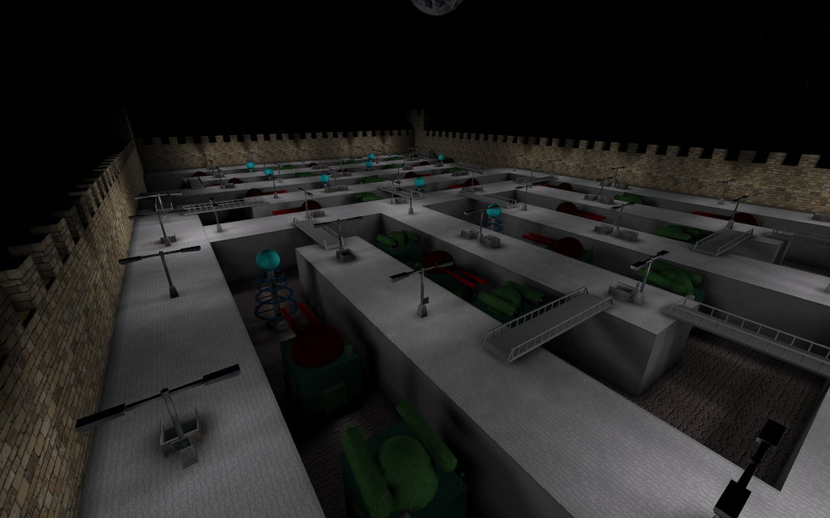[/spoiler]

Strange ~ *Lethalvortex*

KF-Strangev12.rom

Workshop - [steamcommunity.com/sharedfiles/filedetails/?id=112929530](http://steamcommunity.com/sharedfiles/filedetails/?id=112929530)

Форум - [forums.tripwireinteractive.com/showthread.php?t=34589](http://forums.tripwireinteractive.com/showthread.php?t=34589)

D/L - [mediafire.com/download/90b9eeore8zoq26/KF-Strangev12.zip](http://www.mediafire.com/download/90b9eeore8zoq26/KF-Strangev12.zip)[spoiler]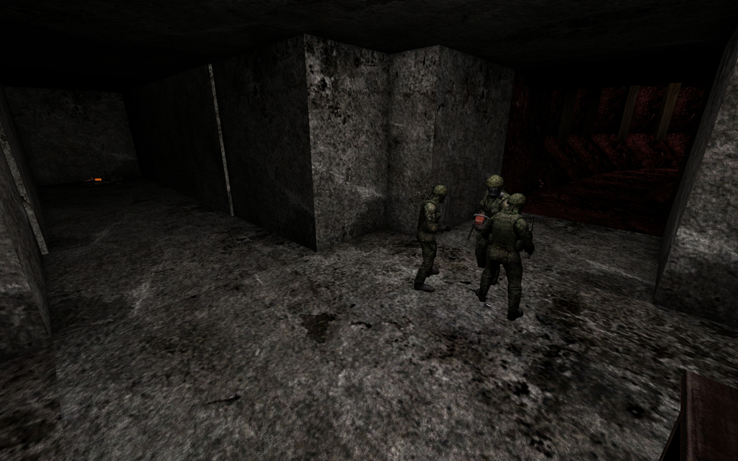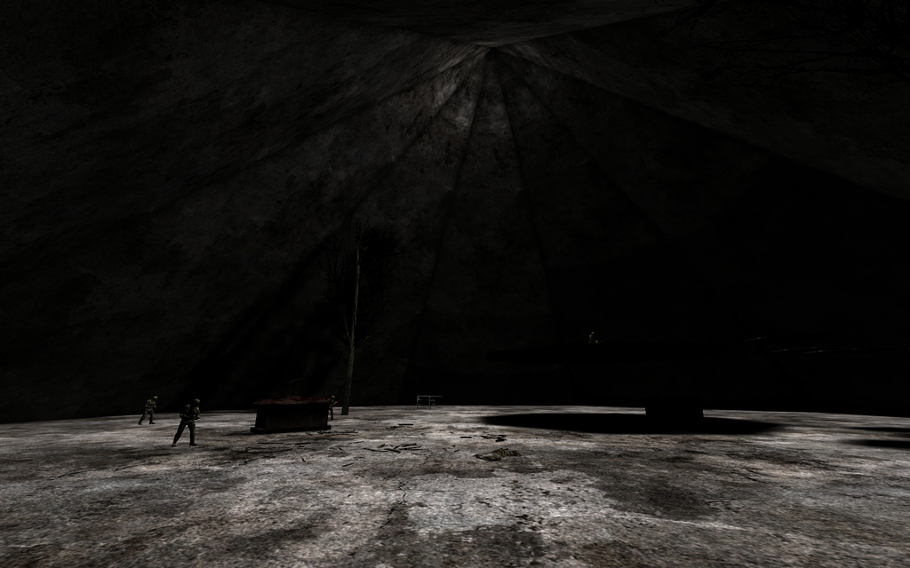[/spoiler]

Hokuto Ujou Hagan Ken ~ *KOTS is GOD*

KF-Hokuto_Ujou_Hagan_Ken_v2.rom

D/L  - [mediafire.com/download/3ujbl5dh9edv7fi/KF-Hokuto_Ujou_Hagan_Ken_v2.zip](http://www.mediafire.com/download/3ujbl5dh9edv7fi/KF-Hokuto_Ujou_Hagan_Ken_v2.zip)[spoiler]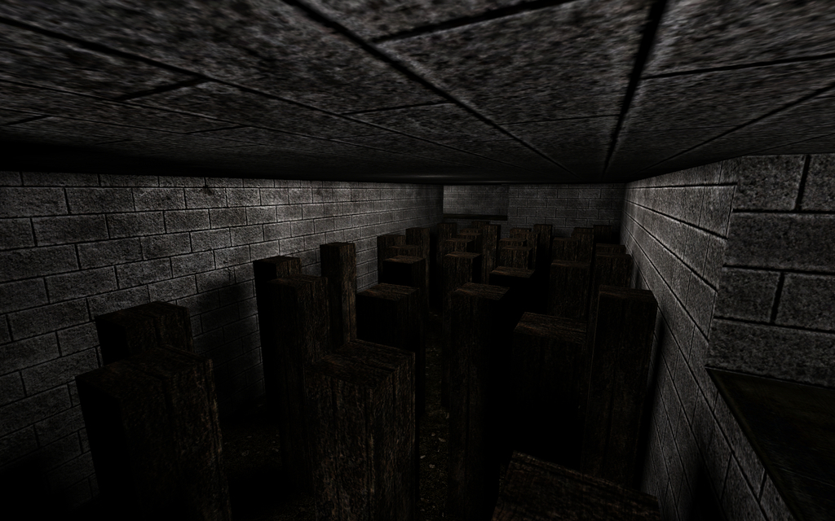[/spoiler]

Rainy Day ~ *RoBoT\**

KF-RainyDay.rom

Workshop - [steamcommunity.com/sharedfiles/filedetails/?id=98080423](http://steamcommunity.com/sharedfiles/filedetails/?id=98080423)

Форум - [forums.tripwireinteractive.com/showthread.php?t=53254](http://forums.tripwireinteractive.com/showthread.php?t=53254)

ModDb - [moddb.com/games/killing-floor/addons/kf-rainyday](http://www.moddb.com/games/killing-floor/addons/kf-rainyday)

D /L  - [mediafire.com/download/eeqvetlhuj0nhet/KF-RainyDay.zip](http://www.mediafire.com/download/eeqvetlhuj0nhet/KF-RainyDay.zip)[spoiler]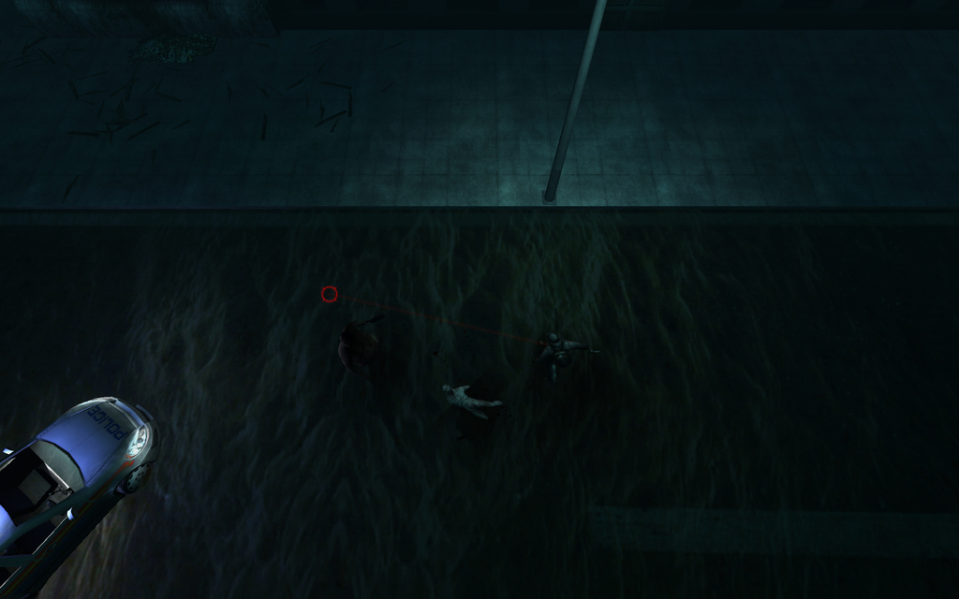[/spoiler]

Survival ~ *RoBoT*

KF-Survival-v2.rom

Workshop - [steamcommunity.com/sharedfiles/filedetails/?id=98085688](http://steamcommunity.com/sharedfiles/filedetails/?id=98085688)

Форум - [forums.tripwireinteractive.com/showthread.php?t=50771](http://forums.tripwireinteractive.com/showthread.php?t=50771)

ModDb - [moddb.com/games/killing-floor/addons/kf-survival-v2](http://www.moddb.com/games/killing-floor/addons/kf-survival-v2)

D/L - [mediafire.com/download/5rb75mswknmrnxv/KF-Survival-v2.zip](http://www.mediafire.com/download/5rb75mswknmrnxv/KF-Survival-v2.zip)[spoiler][/spoiler]

Office Barricade Trader mode ~ *RoBoT*

KF-Offices[BT].rom

ModDb - [moddb.com/games/killing-floor/addons/kf-officesbt](http://www.moddb.com/games/killing-floor/addons/kf-officesbt)

D/L - [mediafire.com/download/u540bwmt1zphjen/KF-OfficesBT.zip](http://www.mediafire.com/download/u540bwmt1zphjen/KF-OfficesBT.zip)[spoiler]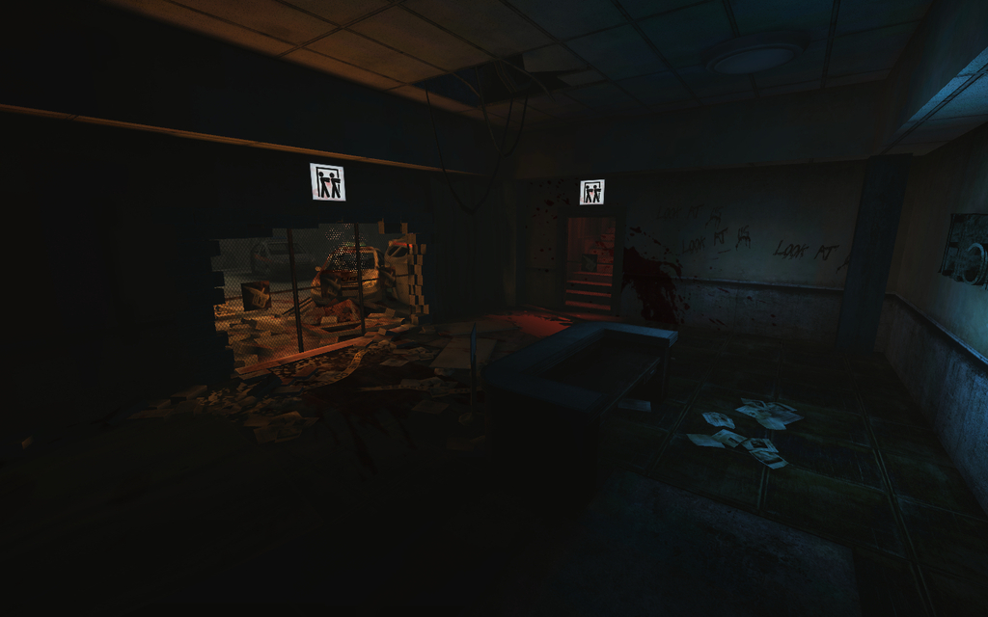[/spoiler][/spoiler]

**Objective Mode**

**Заметки**

***-*** Карты, которые конвертированы в KFO из story/ mission силами своих создателей, будут только в этом разделе.

**-** Для запуска выделенного сервера

Game=KFStoryGame.KFStoryGameInfo

[spoiler]Peak ~ *Fel*

KFO-Peak.rom

Workshop - [steamcommunity.com/sharedfiles/filedetails/?id=189074614](http://steamcommunity.com/sharedfiles/filedetails/?id=189074614)

Форум - [forums.tripwireinteractive.com/showthread.php?t=95876](http://forums.tripwireinteractive.com/showthread.php?t=95876)

D/L - [mediafire.com/download/pgr1140rqw80687/KFO-Peak.zip](http://www.mediafire.com/download/pgr1140rqw80687/KFO-Peak.zip) [spoiler]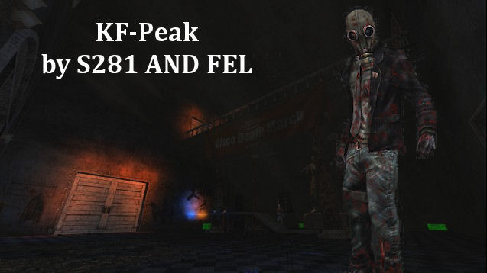[/spoiler]

Once Upon A Time In Mexico ~ *Fel*

KFO-OnceUponATimeInMexico.rom

Workshop - [steamcommunity.com/sharedfiles/filedetails/?id=190214076](http://steamcommunity.com/sharedfiles/filedetails/?id=190214076)

Форум - [forums.tripwireinteractive.com/showthread.php?t=93600](http://forums.tripwireinteractive.com/showthread.php?t=93600)

D/L - [mediafire.com/download/328n3qa4n2upxbu/KFO-OnceUponATimeInMexico.zip](http://www.mediafire.com/download/328n3qa4n2upxbu/KFO-OnceUponATimeInMexico.zip) [spoiler]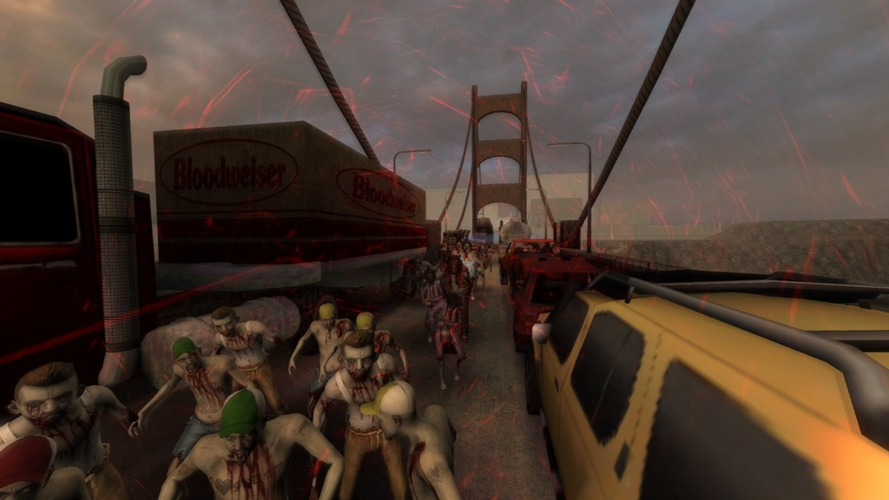[/spoiler]

Resident Evil 1 Mansion ~ Driftwood

KFO-RE1-Mansion-V4.rom

Workshop - [steamcommunity.com/sharedfiles/filedetails/?id=399639299](http://steamcommunity.com/sharedfiles/filedetails/?id=399639299)

Форум - [forums.tripwireinteractive.com/showthread.php?t=43498](http://forums.tripwireinteractive.com/showthread.php?t=43498)

D/L - [mediafire.com/download/lxb2c33al5091io/KFO-RE1-Mansion-V4.zip](http://www.mediafire.com/download/lxb2c33al5091io/KFO-RE1-Mansion-V4.zip)[spoiler]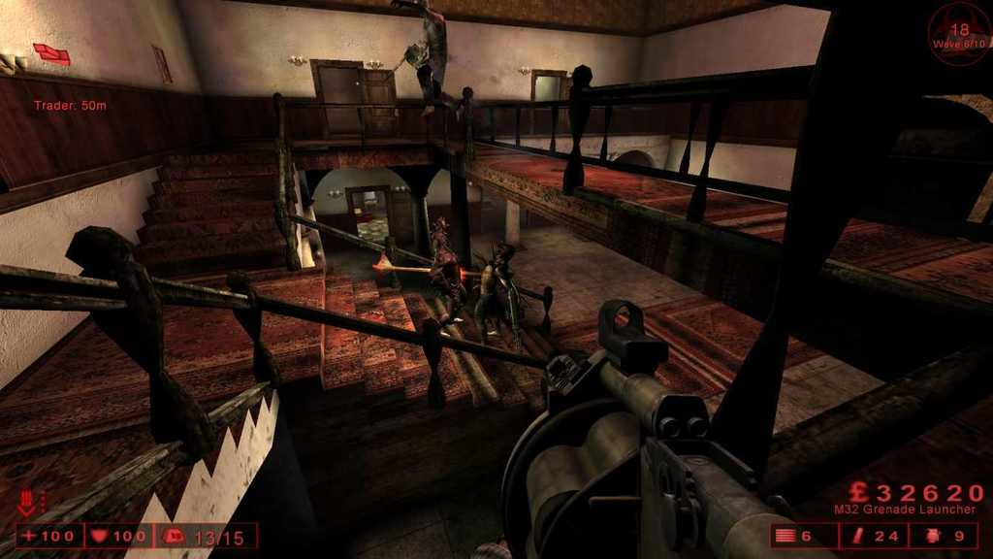[/spoiler]

Manufractured ~ *Smiff*

KFO-ManufracturedB2.rom

Workshop - [steamcommunity.com/sharedfiles/filedetails/?id=172817252](http://steamcommunity.com/sharedfiles/filedetails/?id=172817252)

Форум - [forums.tripwireinteractive.com/showthread.php?t=94846](http://forums.tripwireinteractive.com/showthread.php?t=94846)

D/L - [mediafire.com/download/c06evi565timp12/KFO-ManufracturedB2.zip](http://www.mediafire.com/download/c06evi565timp12/KFO-ManufracturedB2.zip) [spoiler]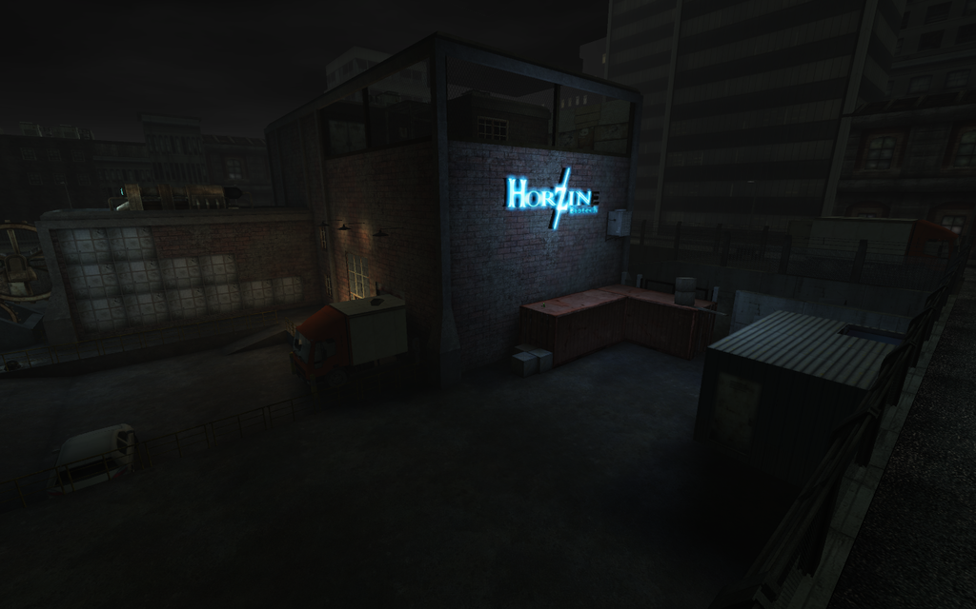[/spoiler]

Foundry (ScrN Ver.) ~ *Poosh*

KFO-Foundry-SE.rom

Workshop - [steamcommunity.com/sharedfiles/filedetails/?id=207486983](http://steamcommunity.com/sharedfiles/filedetails/?id=207486983)

Форум - [forums.tripwireinteractive.com/showthread.php?t=95967](http://forums.tripwireinteractive.com/showthread.php?t=95967)

D/L - [mediafire.com/download/nyd4930lbs2bcek/KFO-Foundry-SE.zip](http://www.mediafire.com/download/nyd4930lbs2bcek/KFO-Foundry-SE.zip) [spoiler]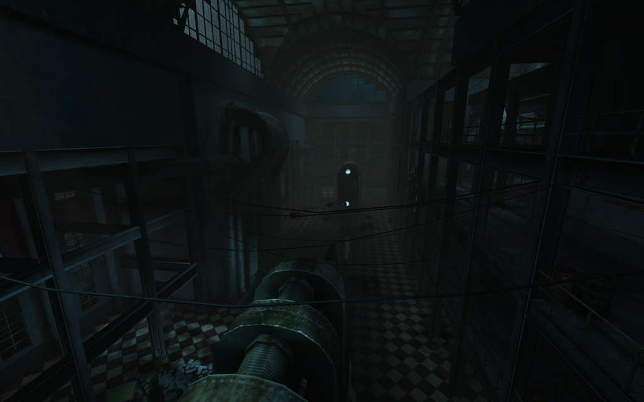[/spoiler]

Station ~ *HIUFIGYO*

KFO-Stationv1-2.rom

Workshop - [steamcommunity.com/sharedfiles/filedetails/?id=222972534](http://steamcommunity.com/sharedfiles/filedetails/?id=222972534)

D/L - [mediafire.com/download/4jjtxjqmb466ji6/KFO-Stationv1-2.zip](http://www.mediafire.com/download/4jjtxjqmb466ji6/KFO-Stationv1-2.zip)[spoiler]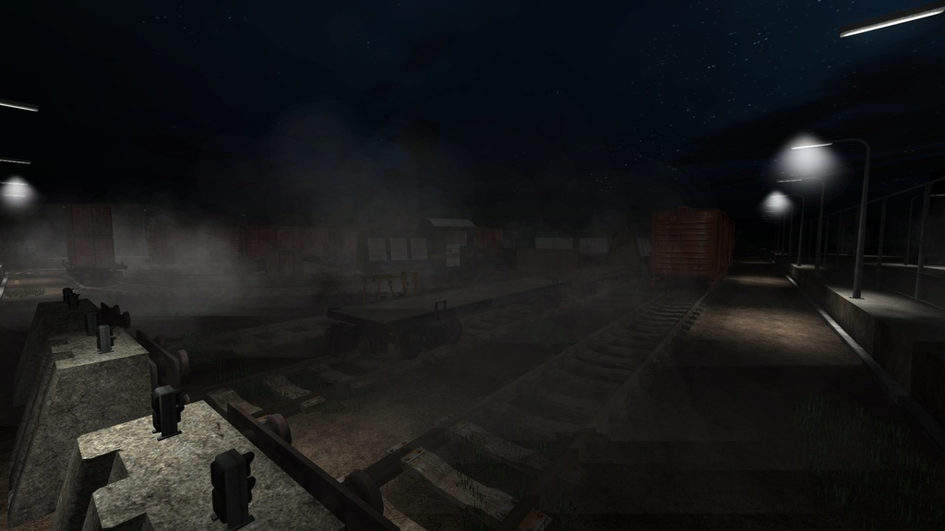[/spoiler]

Filth's Cross ~ *The Hunter*

KFO-FilthsCross.rom

D/L - [mediafire.com/download/gj0g9isvwt23g09/KFO-FilthsCross.zip](http://www.mediafire.com/download/gj0g9isvwt23g09/KFO-FilthsCross.zip)[spoiler]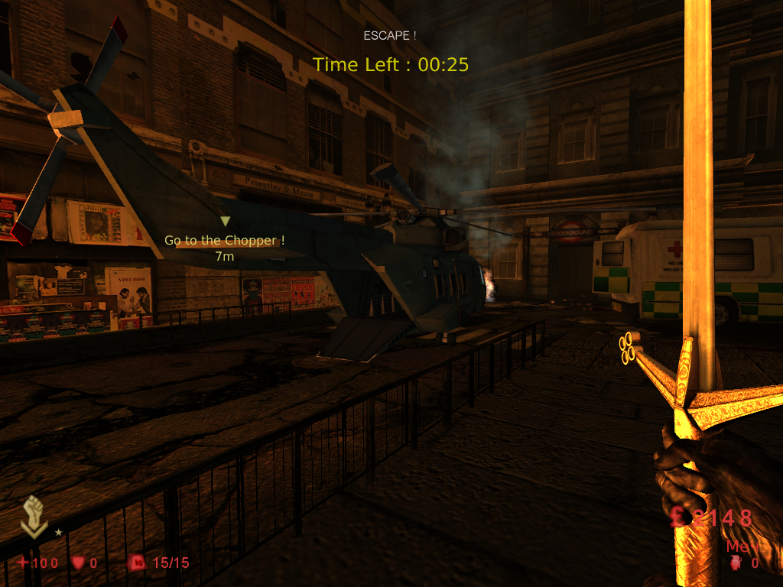[/spoiler]

West London V1.3 ~ *The Hunter*

KFO-WestLondon-FE.rom

Workshop - [steamcommunity.com/sharedfiles/filedetails/?id=254449534](http://steamcommunity.com/sharedfiles/filedetails/?id=254449534)

Форум - [forums.tripwireinteractive.com/showthread.php?t=98295](http://forums.tripwireinteractive.com/showthread.php?t=98295)

D/L - [mediafire.com/download/q7bbl7doseds5n5/KFO-WestLondon-FE.zip](http://www.mediafire.com/download/q7bbl7doseds5n5/KFO-WestLondon-FE.zip)[spoiler]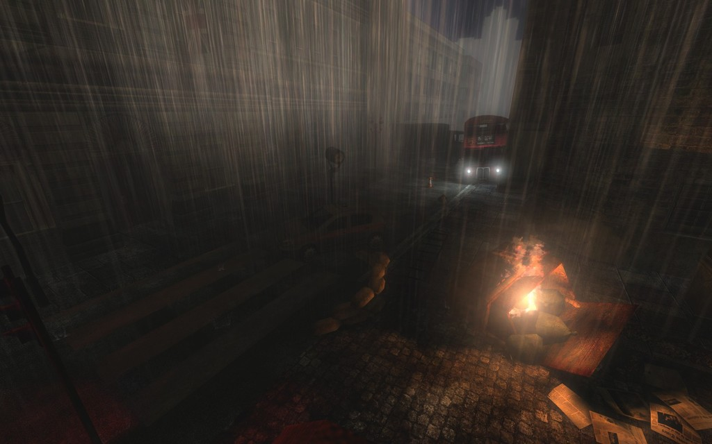[/spoiler]

West London - Survival ~ *The Hunter*

KFO-WestLondon-Survival.rom

Workshop - [steamcommunity.com/sharedfiles/filedetails/?id=264566391](http://steamcommunity.com/sharedfiles/filedetails/?id=264566391)

D/L - [mediafire.com/download/u0ije5l1ofqceox/KFO-WestLondon-Survival.zip](http://www.mediafire.com/download/u0ije5l1ofqceox/KFO-WestLondon-Survival.zip)[spoiler]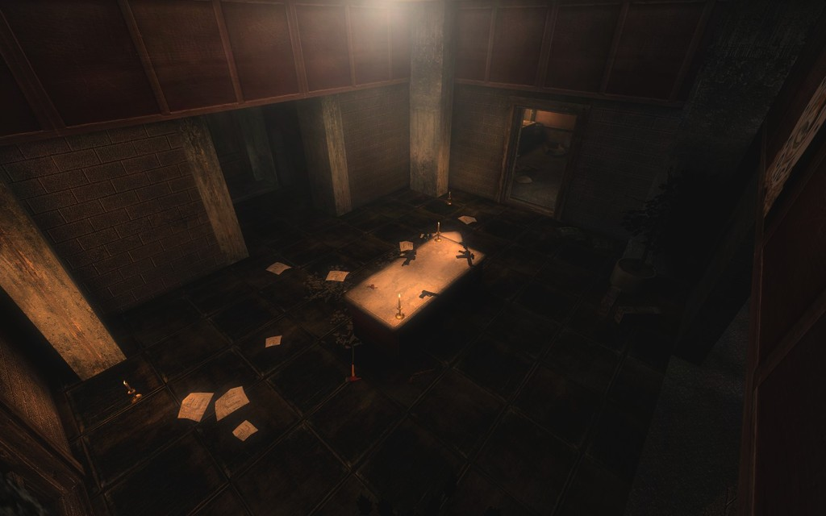[/spoiler]

Biotics Lab - Survival ~ *The Hunter*

KFO-[Survival]-BioticsLab.rom

Workshop - [steamcommunity.com/sharedfiles/filedetails/?id=289213740](http://steamcommunity.com/sharedfiles/filedetails/?id=289213740)

D/L - [mediafire.com/download/pab53zv1fx7d5ks/KFO-%5BSurvival%5D-BioticsLab.zip](http://www.mediafire.com/download/pab53zv1fx7d5ks/KFO-%5BSurvival%5D-BioticsLab.zip)[spoiler]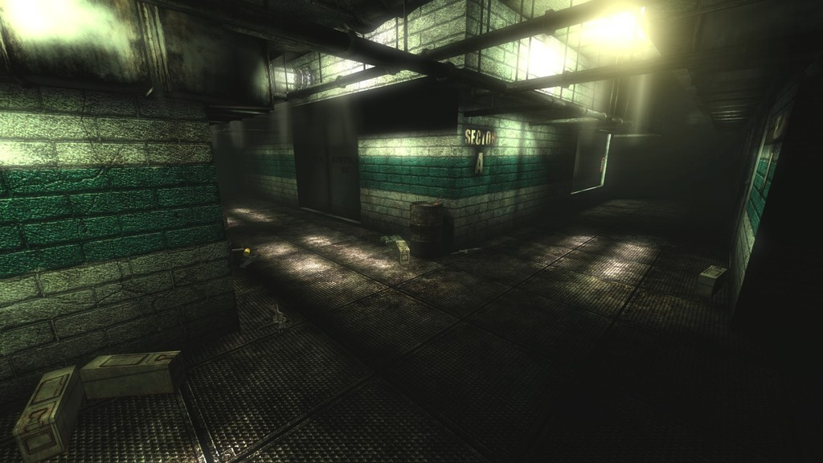[/spoiler]

Manor - Survival ~ *The Hunter*

KFO-[Survival]-Manor.rom

Workshop - [steamcommunity.com/sharedfiles/filedetails/?id=322218109](http://steamcommunity.com/sharedfiles/filedetails/?id=322218109)

D/L - [mediafire.com/download/8n30ecg0d829113/KFO-%5BSurvival%5D-Manor.zip](http://www.mediafire.com/download/8n30ecg0d829113/KFO-%5BSurvival%5D-Manor.zip)[spoiler]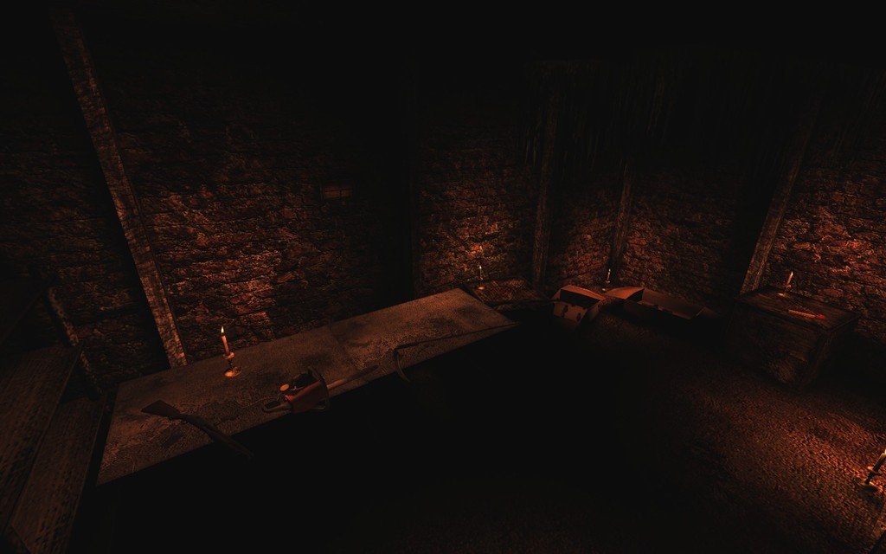[/spoiler]

Manor - Defence ~ *Cakedog\**

KFO-ManorDefence.rom

Workshop - [steamcommunity.com/sharedfiles/filedetails/?id=299954443](http://steamcommunity.com/sharedfiles/filedetails/?id=299954443)

D/L - [mediafire.com/download/d4195j4qa1b55fm/KFO-ManorDefence.zip](http://www.mediafire.com/download/d4195j4qa1b55fm/KFO-ManorDefence.zip)[spoiler]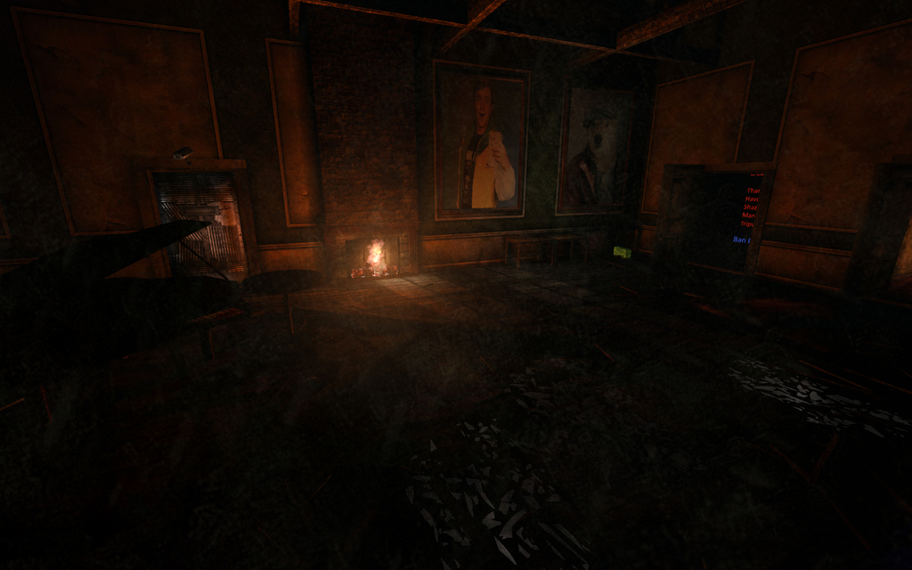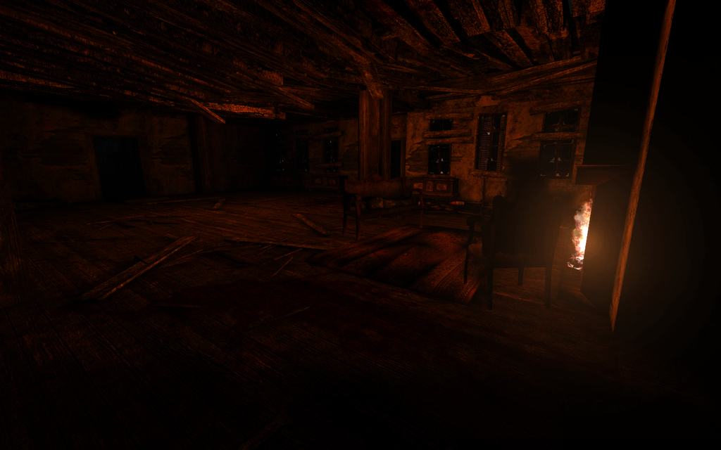[/spoiler]

Planetary Battlegrounds Z ~ *GunsForBucks*

KFO-PlanetaryBattlegroundsZ_Beta01_ws.rom

Workshop -[steamcommunity.com/sharedfiles/filedetails/?id=354970200](http://steamcommunity.com/sharedfiles/filedetails/?id=354970200)

D/L - [mediafire.com/download/ddy19sf7vlqocw1/KFO-PlanetaryBattlegroundsZ_Beta01_ws.zip](http://www.mediafire.com/download/ddy19sf7vlqocw1/KFO-PlanetaryBattlegroundsZ_Beta01_ws.zip)[spoiler]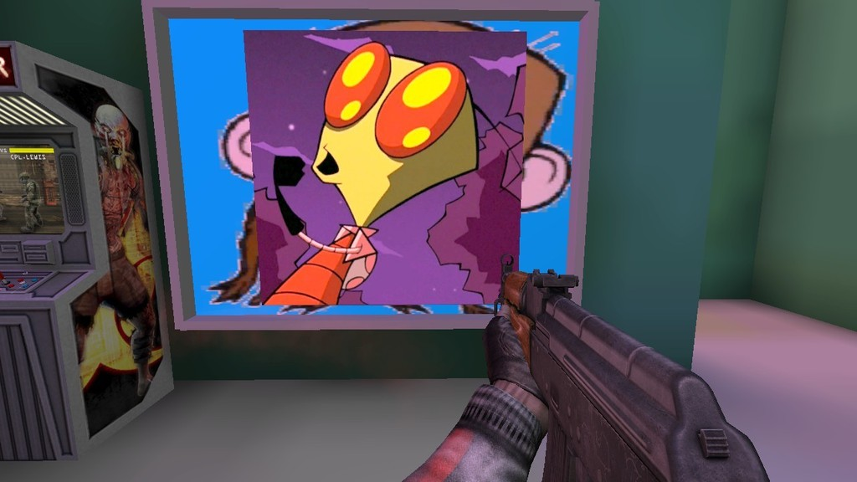[/spoiler]

Soylent Zed ~ *GunsForBucks*

KFO-SoylentZed_multiplayer_Final_ws.rom

Workshop - [steamcommunity.com/sharedfiles/filedetails/?id=253942341](http://steamcommunity.com/sharedfiles/filedetails/?id=253942341)

Форум - [forums.tripwireinteractive.com/showthread.php?t=99137](http://forums.tripwireinteractive.com/showthread.php?t=99137)

D/L - [mediafire.com/download/z1l4fbxt4vm2eq1/KFO-SoylentZed_multiplayer_Final_ws.zip](http://www.mediafire.com/download/z1l4fbxt4vm2eq1/KFO-SoylentZed_multiplayer_Final_ws.zip) [spoiler]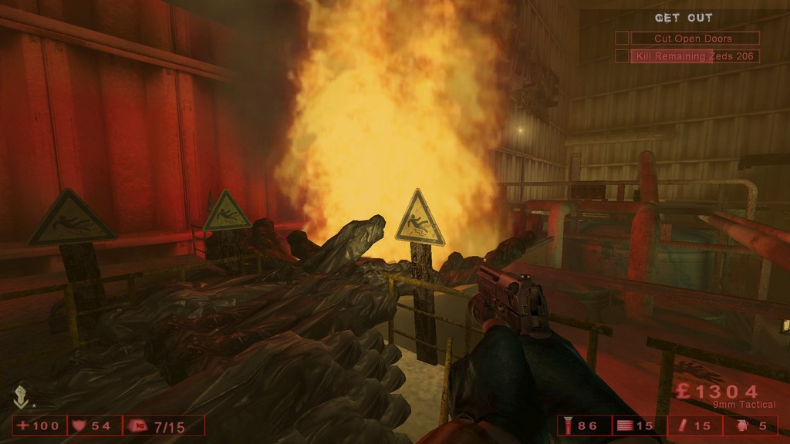[/spoiler]

Soylent Zed (соло версия) ~ *GunsForBucks*

KFO-SoylentZed_Final_Solo_ws.rom

Workshop - [steamcommunity.com/sharedfiles/filedetails/?id=515857446](http://steamcommunity.com/sharedfiles/filedetails/?id=515857446)

D/L - [mediafire.com/download/2454898q4e2ne1o/KFO-SoylentZed_Final_Solo_ws.zip](http://www.mediafire.com/download/2454898q4e2ne1o/KFO-SoylentZed_Final_Solo_ws.zip)

Fleshpound Challenge ~ *GunsForBucks*

Будут появляться только фп. Имейте в виду, что система агра как в старых версиях KF.[spoiler]Biotics Lab FPC

KFO-FPChallenge_BioticsLab_V00_WS.rom

Workshop - [steamcommunity.com/sharedfiles/filedetails/?id=259447743](http://steamcommunity.com/sharedfiles/filedetails/?id=259447743)

D/L - [mediafire.com/download/a3rsx4uxp5d62vw/KFO-FPChallenge_BioticsLab_V00_WS.zip](http://www.mediafire.com/download/a3rsx4uxp5d62vw/KFO-FPChallenge_BioticsLab_V00_WS.zip)

Departed FPC

KFO-FPC_Departed_V00_WS.rom

Workshop - [steamcommunity.com/sharedfiles/filedetails/?id=259770076](http://steamcommunity.com/sharedfiles/filedetails/?id=259770076)

D/L - [mediafire.com/download/c9da7s88ckizwgw/KFO-FPC_Departed_V00_WS.zip](http://www.mediafire.com/download/c9da7s88ckizwgw/KFO-FPC_Departed_V00_WS.zip)

Fright Yard FPC

KFO-FPChallenge_FrightYard_V00_WS.rom

Workshop - [steamcommunity.com/sharedfiles/filedetails/?id=259310079](http://steamcommunity.com/sharedfiles/filedetails/?id=259310079)

D/L - [mediafire.com/download/ce9z2dijgb6r6dd/KFO-FPChallenge_FrightYard_V00_WS.zip](http://www.mediafire.com/download/ce9z2dijgb6r6dd/KFO-FPChallenge_FrightYard_V00_WS.zip)

Ice Breaker FPC

KFO-FPC_Icebreaker.rom

Workshop - [steamcommunity.com/sharedfiles/filedetails/?id=673350154](http://steamcommunity.com/sharedfiles/filedetails/?id=673350154)

D/L - [mediafire.com/download/cvy7aaospyd3o7x/KFO-FPC_Icebreaker.zip](http://www.mediafire.com/download/cvy7aaospyd3o7x/KFO-FPC_Icebreaker.zip)

Moonbase FPC

KFO-FPC-MoonBase_V00_WS.rom

Workshop - [steamcommunity.com/sharedfiles/filedetails/?id=259730854](http://steamcommunity.com/sharedfiles/filedetails/?id=259730854)

D/L - [mediafire.com/download/zkpzrppxn7ejkwa/KFO-FPC-MoonBase_V00_WS.zip](http://www.mediafire.com/download/zkpzrppxn7ejkwa/KFO-FPC-MoonBase_V00_WS.zip)

Moonbase: Sirens vs Husks FPC

KFO-HuskVsSiren-MoonBase_V00-WS.rom

Workshop - [steamcommunity.com/sharedfiles/filedetails/?id=264529260](http://steamcommunity.com/sharedfiles/filedetails/?id=264529260)

D/L - [mediafire.com/download/2hvqsfssi9d7vmm/KFO-HuskVsSiren-MoonBase_V00-WS.zip](http://www.mediafire.com/download/2hvqsfssi9d7vmm/KFO-HuskVsSiren-MoonBase_V00-WS.zip)

Sibyl Complex FPC

KFO-FP_Challenge_SibylComplex_BetaV00_WS.rom

Workshop - [steamcommunity.com/sharedfiles/filedetails/?id=258378699](http://steamcommunity.com/sharedfiles/filedetails/?id=258378699)

D/L - [mediafire.com/download/0646lo4cuztwvot/KFO-FP_Challenge_SibylComplex_BetaV00_WS.zip](http://www.mediafire.com/download/0646lo4cuztwvot/KFO-FP_Challenge_SibylComplex_BetaV00_WS.zip)

West London FPC

KFO-FPChallenge_WestLondon_V00_WS.rom

Workshop - [steamcommunity.com/sharedfiles/filedetails/?id=259585957](http://steamcommunity.com/sharedfiles/filedetails/?id=259585957)

D/L - [mediafire.com/download/c6w4n2m53e019q2/KFO-FPChallenge_WestLondon_V00_WS.zip](http://www.mediafire.com/download/c6w4n2m53e019q2/KFO-FPChallenge_WestLondon_V00_WS.zip)

Wyre FPC

KFO-FPC_Wyre_ws.rom

Workshop - [steamcommunity.com/sharedfiles/filedetails/?id=359680054](http://steamcommunity.com/sharedfiles/filedetails/?id=359680054)

D/L - [mediafire.com/download/g8n644eqg89663n/KFO-FPC_Wyre_ws.zip](http://www.mediafire.com/download/g8n644eqg89663n/KFO-FPC_Wyre_ws.zip) [/spoiler]

30 wave challenge ~ *HIUFIGYO*

Для любителей хардкора и длинных игр. На каждые 10 волн +1 патриарх.

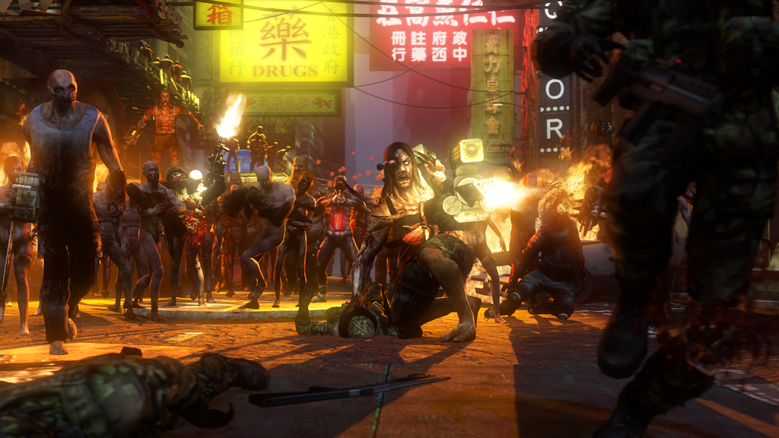[spoiler]Fright Yard 30WC

KFO-FrightYard_30wavechallenge.rom

Workshop - [steamcommunity.com/sharedfiles/filedetails/?id=299267623](http://steamcommunity.com/sharedfiles/filedetails/?id=299267623)

D/L - [mediafire.com/download/18epcoawl0opm3r/KFO-FrightYard_30wavechallenge.zip](http://www.mediafire.com/download/18epcoawl0opm3r/KFO-FrightYard_30wavechallenge.zip)

Hospital Horrors 30WC

KFO-Hospitalhorrors_30wavechallenge.rom

Workshop - [steamcommunity.com/sharedfiles/filedetails/?id=307472605](http://steamcommunity.com/sharedfiles/filedetails/?id=307472605)

D/L - [mediafire.com/download/hha8xv9f5em9t5m/KFO-Hospitalhorrors_30wavechallenge.zip](http://www.mediafire.com/download/hha8xv9f5em9t5m/KFO-Hospitalhorrors_30wavechallenge.zip)

Moonbase 30WC

KFO-MoonBase_30wavechallenge.rom

Workshop - [steamcommunity.com/sharedfiles/filedetails/?id=302962518](http://steamcommunity.com/sharedfiles/filedetails/?id=302962518)

D/L - [mediafire.com/download/bcsd12qeiusgc8k/KFO-MoonBase_30wavechallenge.zip](http://www.mediafire.com/download/bcsd12qeiusgc8k/KFO-MoonBase_30wavechallenge.zip)

Station 30WC

KFO-Station_30wavechallenge.rom

Workshop - [steamcommunity.com/sharedfiles/filedetails/?id=330736115](http://steamcommunity.com/sharedfiles/filedetails/?id=330736115)

D/L - [mediafire.com/download/mokftfsm5am97ot/KFO-Station_30wavechallenge.zip](http://www.mediafire.com/download/mokftfsm5am97ot/KFO-Station_30wavechallenge.zip)

Steamland 30WC

KFO-Steamland_30wavechallenge.rom

Workshop - [steamcommunity.com/sharedfiles/filedetails/?id=290897621](http://steamcommunity.com/sharedfiles/filedetails/?id=290897621)

D/L - [mediafire.com/download/8dk08h1gj2eo24o/KFO-Steamland_30wavechallenge.zip](http://www.mediafire.com/download/8dk08h1gj2eo24o/KFO-Steamland_30wavechallenge.zip) [/spoiler]

Run Kitty Run ~ *Lethal_Vortex*\*

KFO-RunKittyRun_desertv3.rom.

Workshop - [steamcommunity.com/sharedfiles/filedetails/?id=299117328](http://steamcommunity.com/sharedfiles/filedetails/?id=299117328)

D/L - [mediafire.com/download/o6jtyr24w0p4rds/KFO-RunKittyRun_desertv3.zip](http://www.mediafire.com/download/o6jtyr24w0p4rds/KFO-RunKittyRun_desertv3.zip) [spoiler]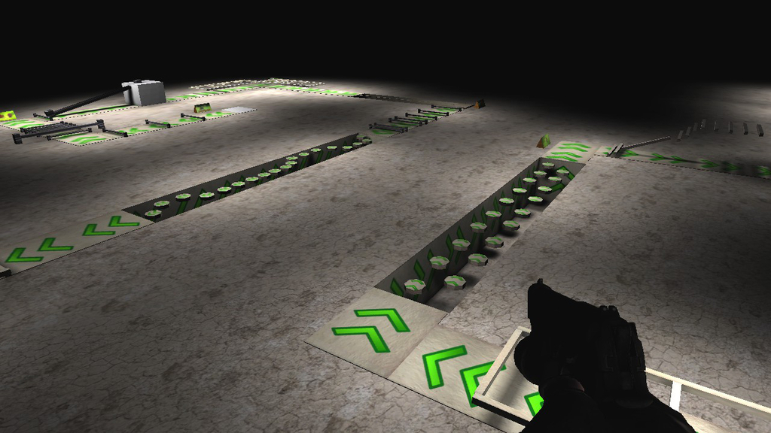[/spoiler]

Hell's Fire ~ *U.N.C.L.E.*\*

KFO-HellsFire.rom

KFO-HellsFire-Expert.rom

KFO-HellsFire-Novice.rom

Workshop - [steamcommunity.com/sharedfiles/filedetails/?id=639953551](http://steamcommunity.com/sharedfiles/filedetails/?id=639953551)

D/L  - [mediafire.com/download/4n3l4rbm7t668vv/KFO-HellsFire.zip](http://www.mediafire.com/download/4n3l4rbm7t668vv/KFO-HellsFire.zip) [spoiler]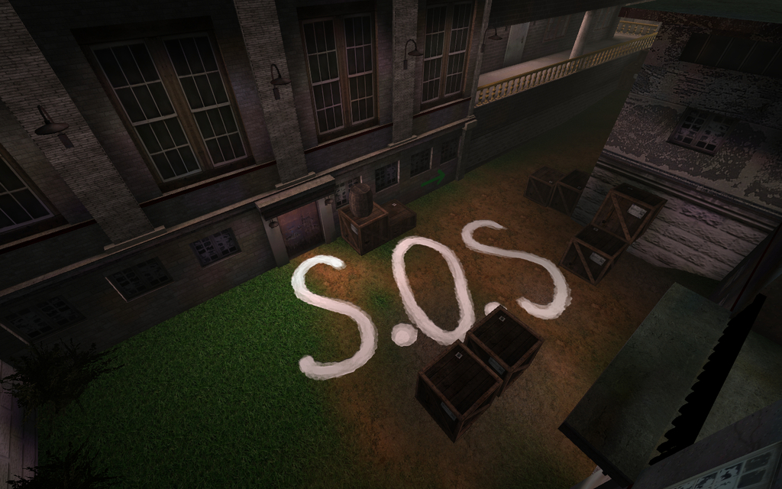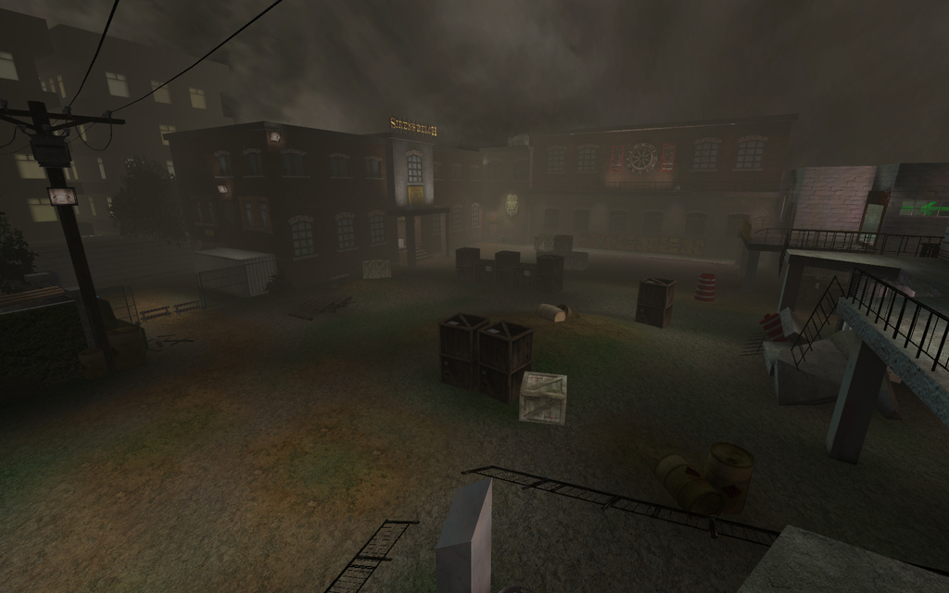[/spoiler]

Boss Arena ~ *Fire*

KFO-BossArena.rom

Workshop - [steamcommunity.com/sharedfiles/filedetails/?id=290037556](http://steamcommunity.com/sharedfiles/filedetails/?id=290037556)

Форум - [forums.tripwireinteractive.com/showthread.php?t=101067](http://forums.tripwireinteractive.com/showthread.php?t=101067)

D/L - [mediafire.com/download/c1b879126qzabpo/KFO-BossArena.zip](http://www.mediafire.com/download/c1b879126qzabpo/KFO-BossArena.zip) [spoiler]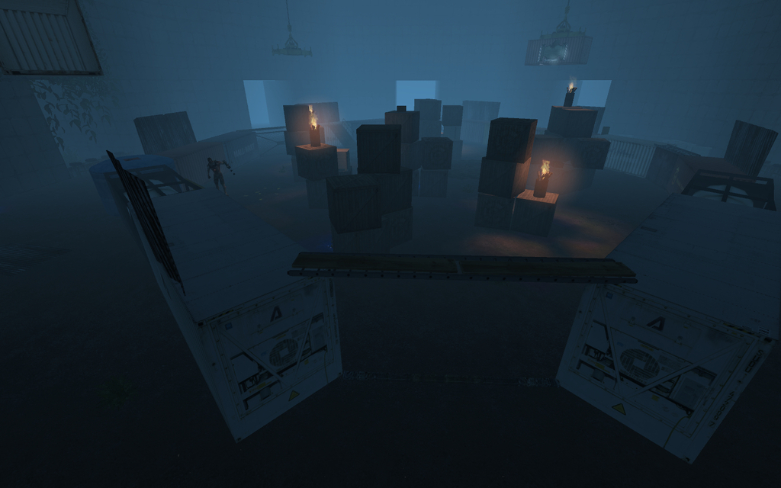[/spoiler]

Lerwick Wonder ~ *PiX*

KFO-LerwickWonder-beta1f.rom

Форум - [forums.tripwireinteractive.com/showthread.php?t=70674](http://forums.tripwireinteractive.com/showthread.php?t=70674)

D/L - [mediafire.com/download/1y74cxnpewqa88x/KFO-LerwickWonder-beta1f.zip](http://www.mediafire.com/download/1y74cxnpewqa88x/KFO-LerwickWonder-beta1f.zip) [spoiler]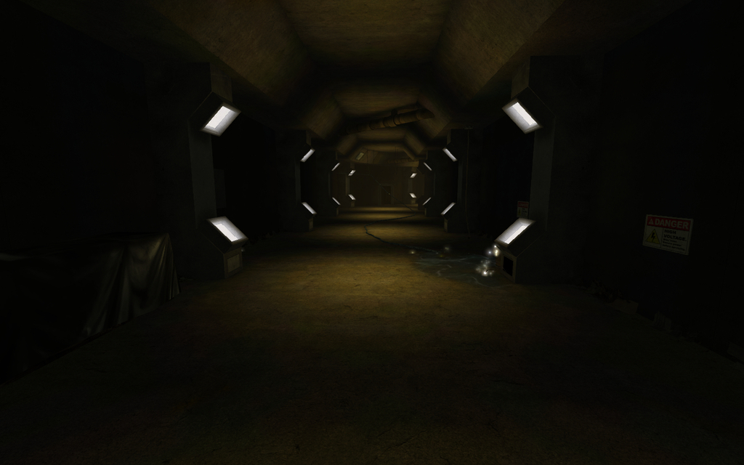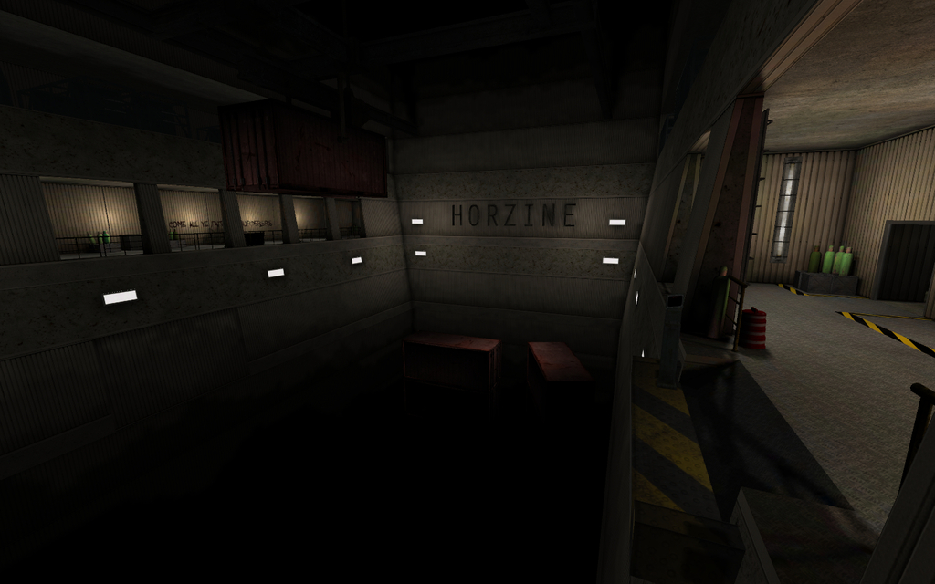[/spoiler]

Haunted Hotel ~ *Mr.RoBoT* & *Marco*\*

KFO-Haunted-Hotel.rom

Workshop - [steamcommunity.com/sharedfiles/filedetails/?id=188440184](http://steamcommunity.com/sharedfiles/filedetails/?id=188440184)

Форум - [forums.tripwireinteractive.com/showthread.php?t=96038](http://forums.tripwireinteractive.com/showthread.php?t=96038)

ModDb - [moddb.com/games/killing-floor/addons/kfo-haunted-hotel](http://www.moddb.com/games/killing-floor/addons/kfo-haunted-hotel)

D/L - [mediafire.com/download/get97w6j877az2m/KFO-Haunted-Hotel.zip](http://www.mediafire.com/download/get97w6j877az2m/KFO-Haunted-Hotel.zip) [spoiler]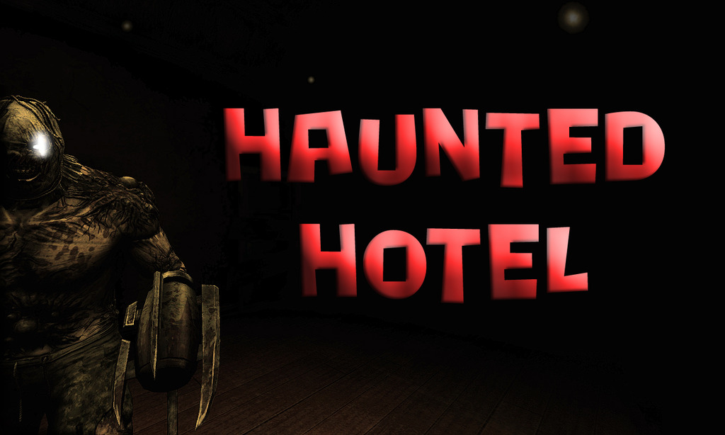[/spoiler]

Endless Map Pack ~ *oiruka101*

KFO-BioticsLab-challenge-endless.rom

KFO-Biohazard-challenge-endless.rom

KFO-EvilSantasLair-challenge-endless.rom

Workshop - [steamcommunity.com/sharedfiles/filedetails/?id=186611598](http://steamcommunity.com/sharedfiles/filedetails/?id=186611598)

D/L - [mediafire.com/download/og1qs9ozliwlshw/Endless+Map+Pack.zip](http://www.mediafire.com/download/og1qs9ozliwlshw/Endless+Map+Pack.zip) [spoiler]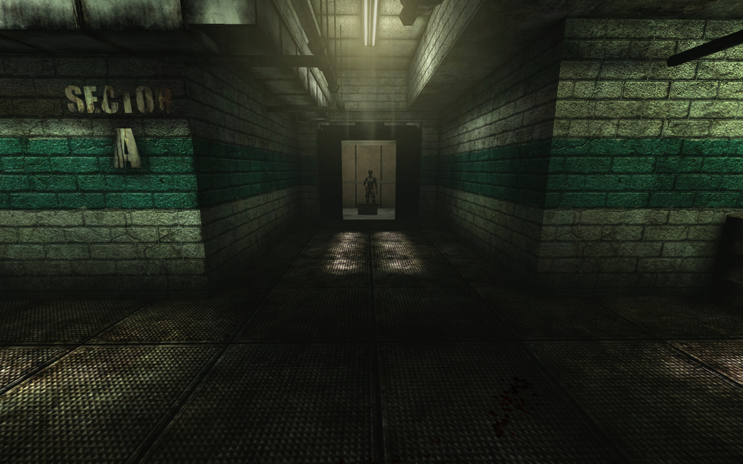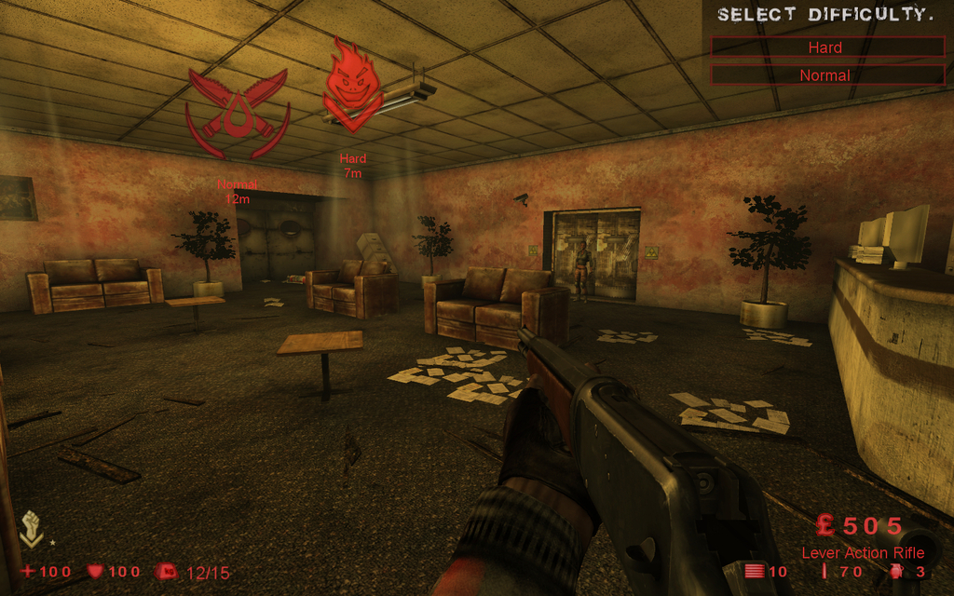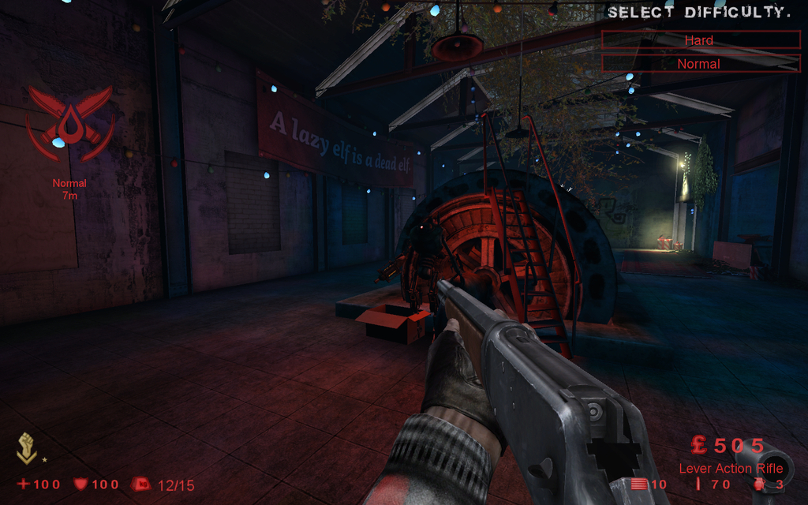[/spoiler]

Containment Station (только для соло) ~ *Fel*

KFO-ContainmentStationBETA.rom

Форум - [forums.tripwireinteractive.com/showthread.php?t=93599](http://forums.tripwireinteractive.com/showthread.php?t=93599)

D/L - [mediafire.com/download/9ux55vonb3at50t/KFO-ContainmentStationBETA.zip](http://www.mediafire.com/download/9ux55vonb3at50t/KFO-ContainmentStationBETA.zip) [spoiler]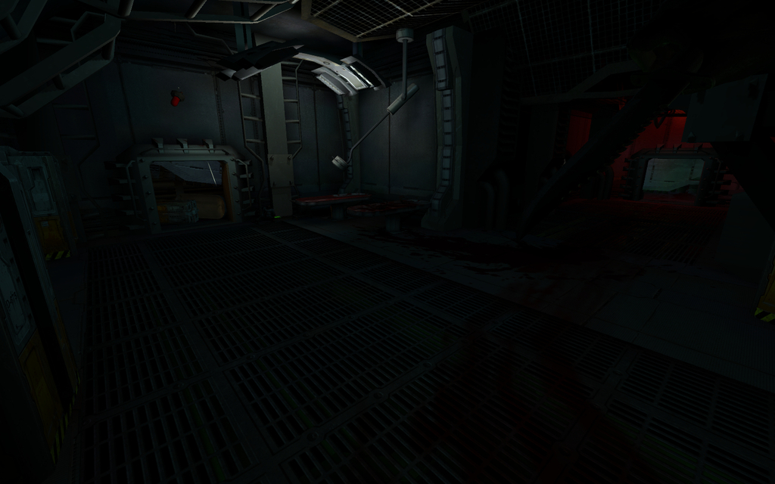[/spoiler]

Snuff (только для соло) ~ *KF_Alex*\*

KFO-SnuffMonkey.rom

Workshop - [steamcommunity.com/sharedfiles/filedetails/?id=171724782](http://steamcommunity.com/sharedfiles/filedetails/?id=171724782)

Форум - [forums.tripwireinteractive.com/showthread.php?t=95222](http://forums.tripwireinteractive.com/showthread.php?t=95222)

D/L - [mediafire.com/download/i4hchfya3d7a5zk/KFO-SnuffMonkey.zip](http://www.mediafire.com/download/i4hchfya3d7a5zk/KFO-SnuffMonkey.zip) [spoiler]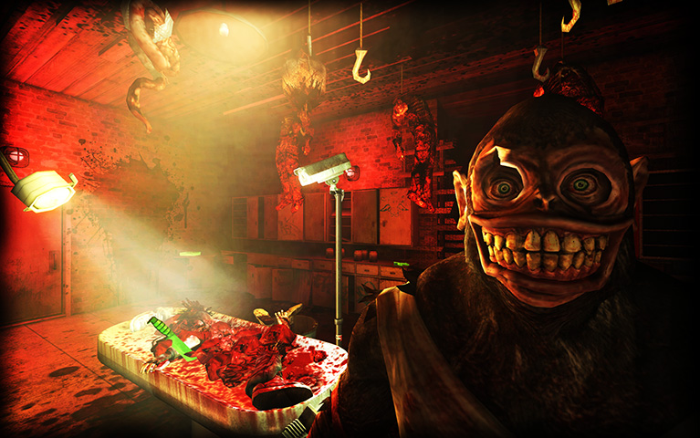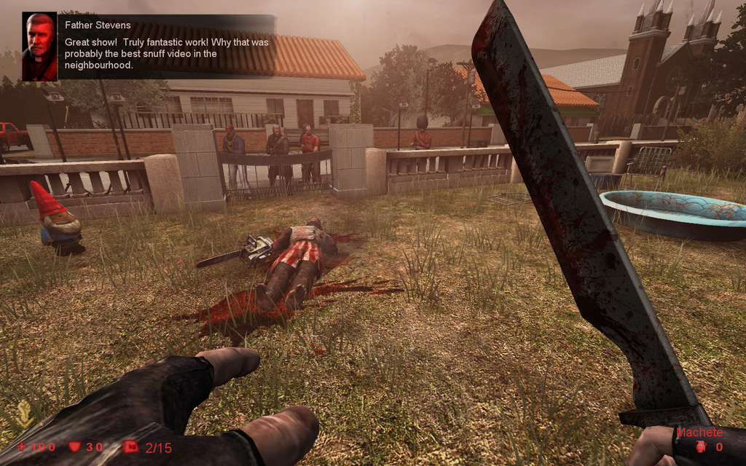[/spoiler][/spoiler]

**Testing Mode**

**Заметки**

***-*** Можно тренироваться, экспериментировать с разным оружием. И главное никто не будет кикать :unsure2:.

***-*** Будут перечислены только работающие, серые карты. А те, что используются для читинга, идут лесом.

[spoiler]The Test Map v2 ~ *Mutant*\*

KF-TheTestmap-2.rom

Workshop - [steamcommunity.com/sharedfiles/filedetails/?id=99193018](http://steamcommunity.com/sharedfiles/filedetails/?id=99193018)

Форум - [forums.tripwireinteractive.com/showthread.php?p=1278045](http://forums.tripwireinteractive.com/showthread.php?p=1278045)

D/L - [mediafire.com/download/5m5qd4lxovhpt36/KF-TheTestmap-2.zip](http://www.mediafire.com/download/5m5qd4lxovhpt36/KF-TheTestmap-2.zip) [spoiler]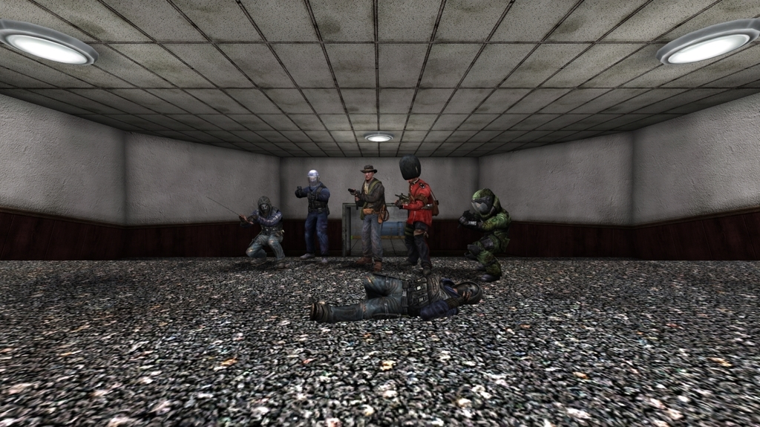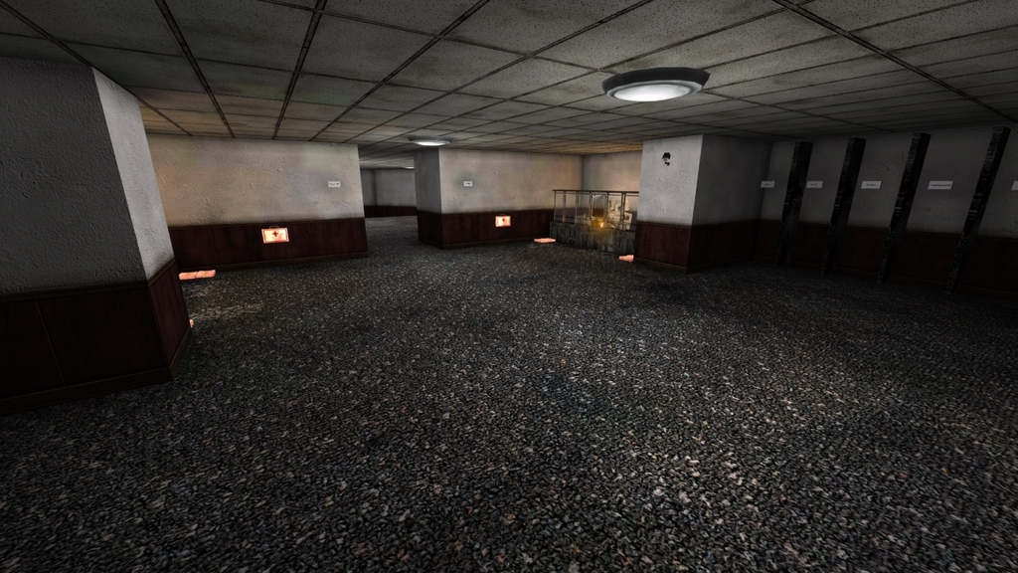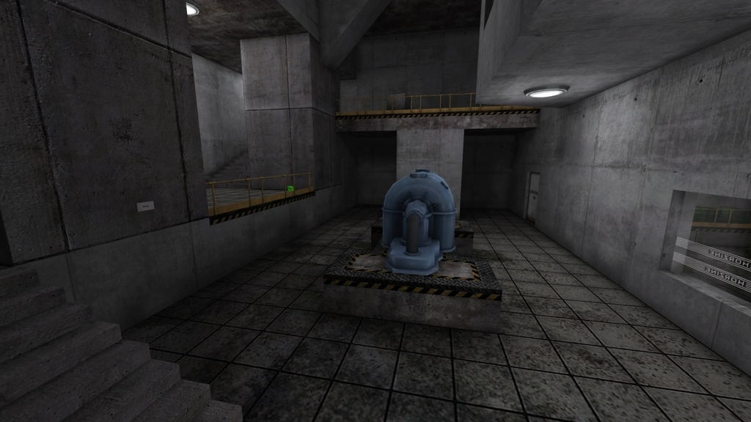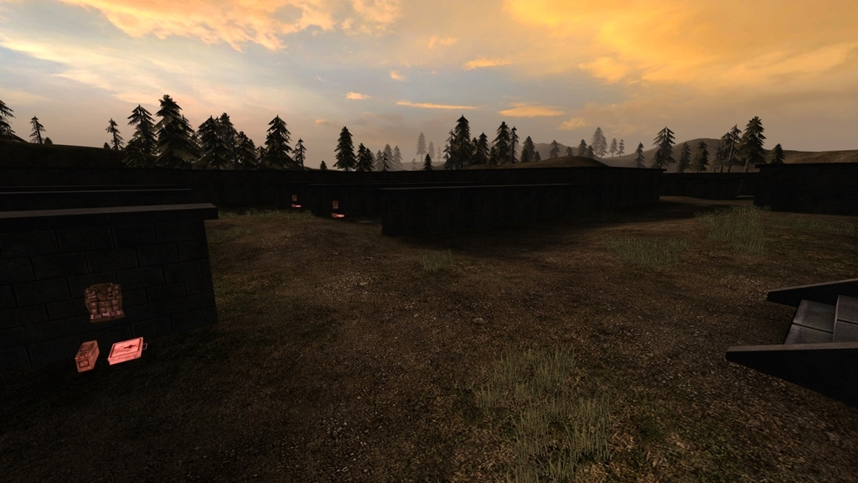[/spoiler]

The Test Map v1 ~ *Mutant*\*

KF-TheTestmap.rom

D/L - [mediafire.com/download/pjmfuuwvuhz170z/KF-TheTestmap.zip](http://www.mediafire.com/download/pjmfuuwvuhz170z/KF-TheTestmap.zip) [spoiler]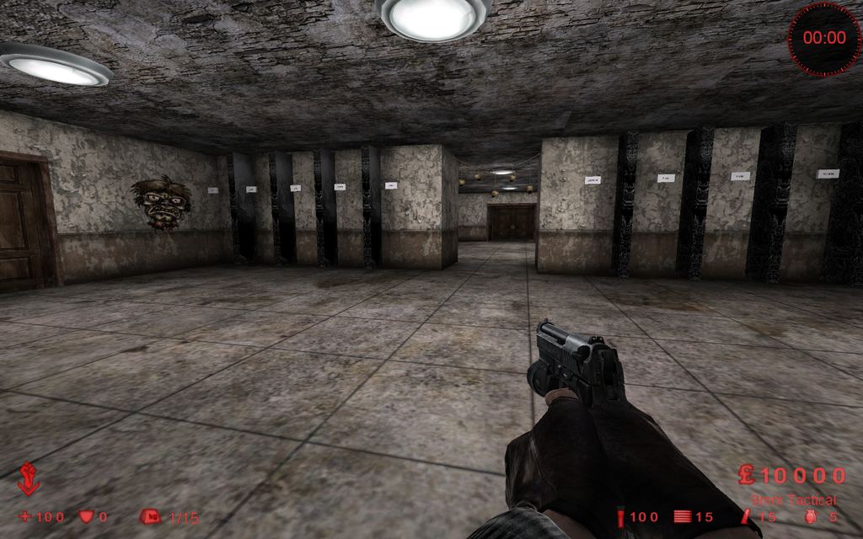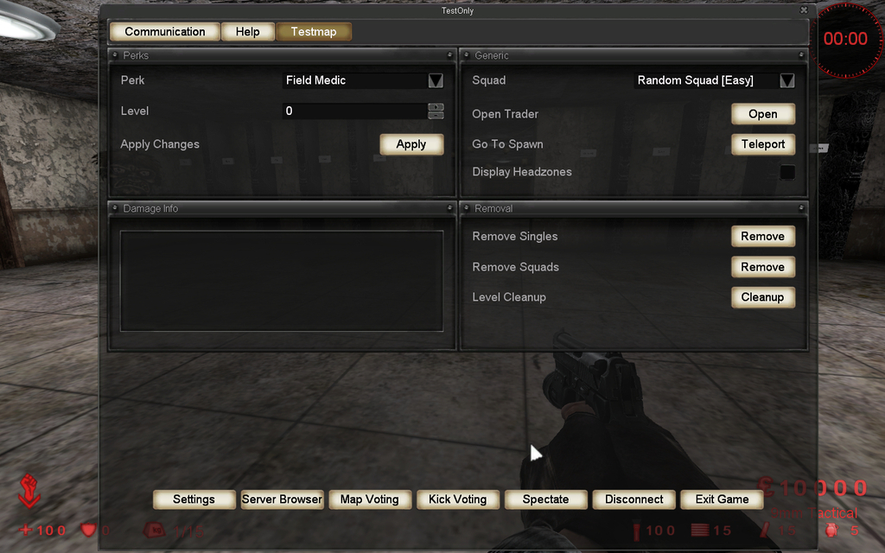[/spoiler]

Steamy Test Map ~ *Skell*\*

KF-SteamyTestMapV3.rom

Workshop - [steamcommunity.com/sharedfiles/filedetails/?id=288451842](http://steamcommunity.com/sharedfiles/filedetails/?id=288451842)

Форум - [forums.tripwireinteractive.com/showthread.php?t=95130](http://forums.tripwireinteractive.com/showthread.php?t=95130)

D/L - [mediafire.com/download/5y6j4dckbs9bnx7/KF-SteamyTestMapV3.zip](http://www.mediafire.com/download/5y6j4dckbs9bnx7/KF-SteamyTestMapV3.zip) [spoiler]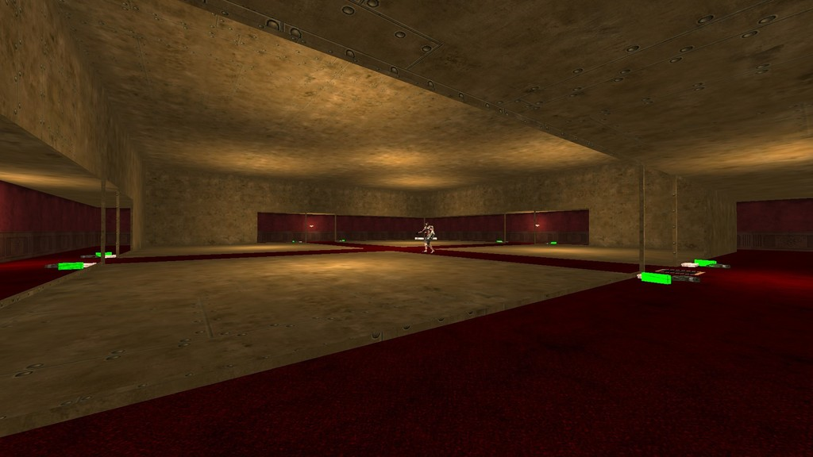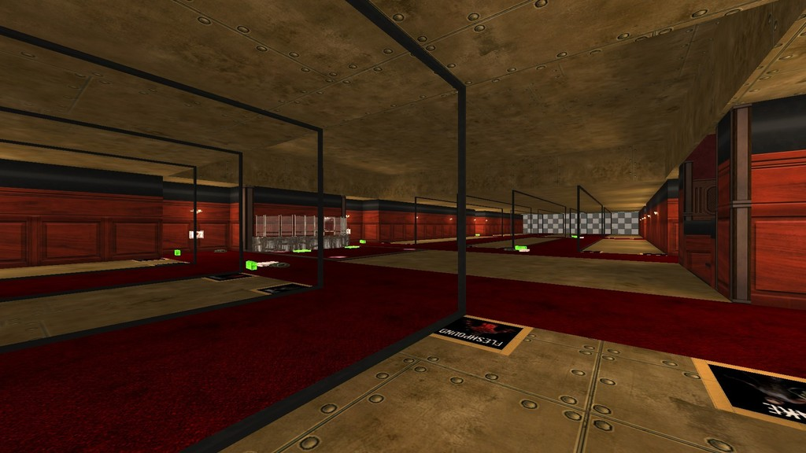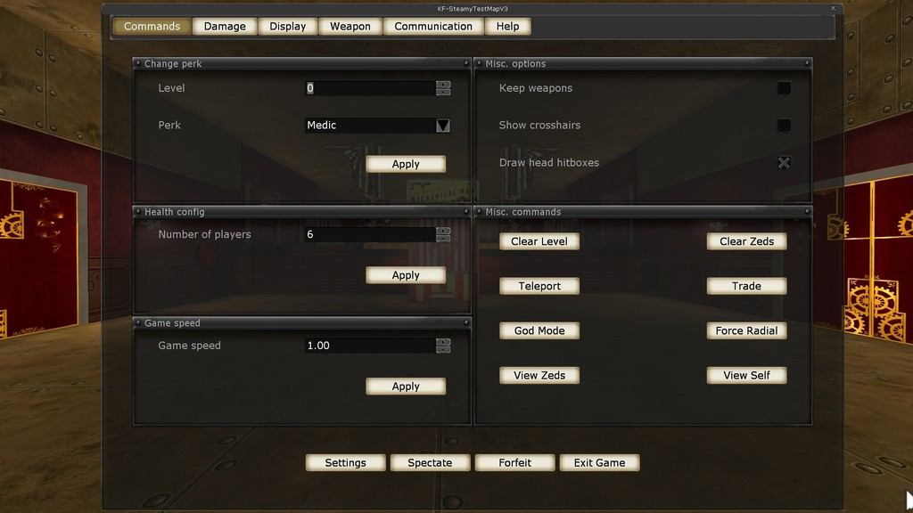[/spoiler]

Steamy Test Map Rodeo Mod ~ *Gladius*\*

KF-SteamyTestMapV3RodeoMod.rom

D/L - [mediafire.com/download/65pjdgww109c4dl/KF-SteamyTestMapV3RodeoMod.zip](http://www.mediafire.com/download/65pjdgww109c4dl/KF-SteamyTestMapV3RodeoMod.zip) [spoiler]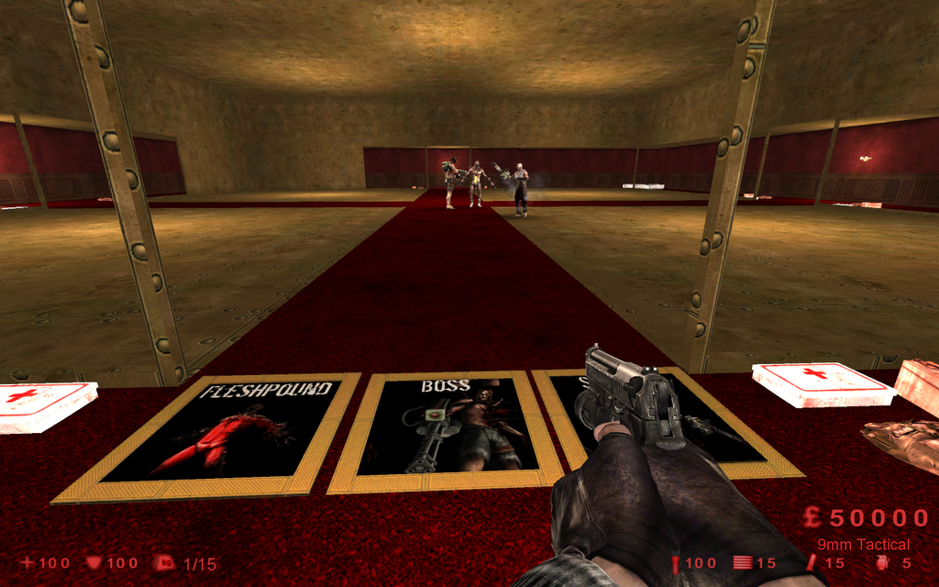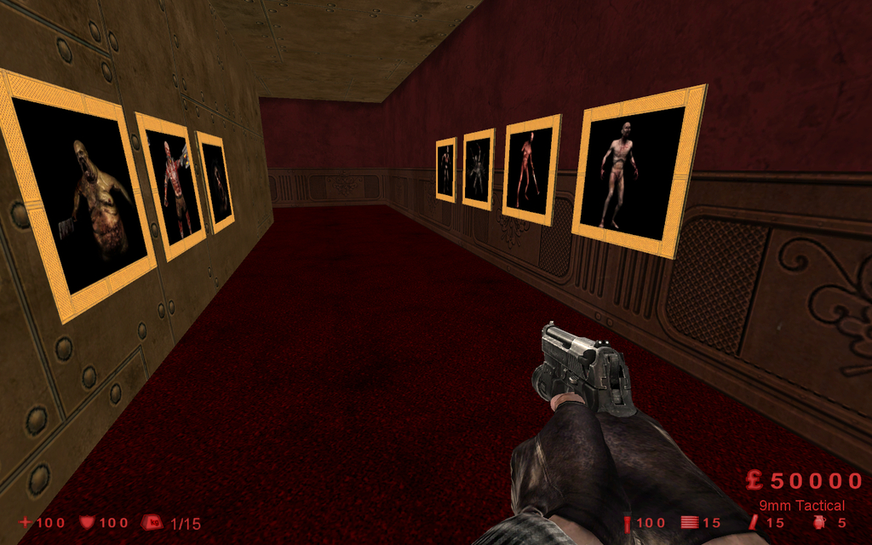[/spoiler]

ScrN Testing Grounds ~ *Poosh*\*

KF-ScrnTestGrounds.rom

Workshop - [steamcommunity.com/sharedfiles/filedetails/?id=312696626](http://steamcommunity.com/sharedfiles/filedetails/?id=312696626)

D/L - [mediafire.com/download/15091afnx1lxugu/KF-ScrnTestGrounds.zip](http://www.mediafire.com/download/15091afnx1lxugu/KF-ScrnTestGrounds.zip) [spoiler]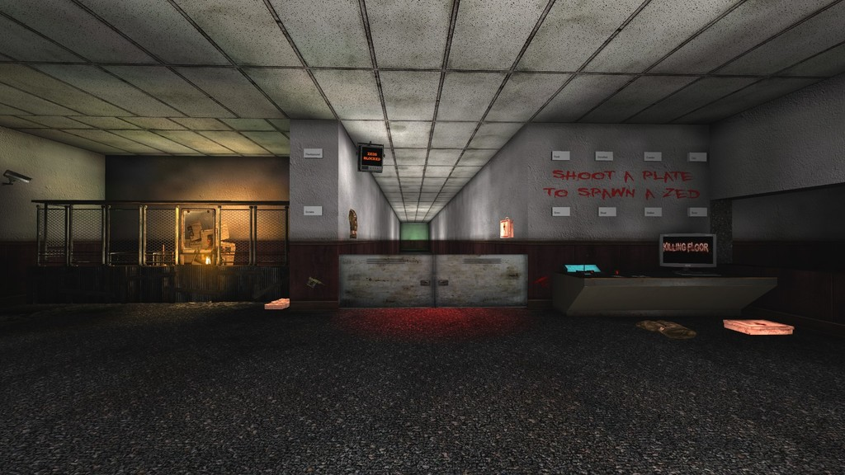[/spoiler][/spoiler]

**Aliens**

**Заметки**

**-** Не рекомендуется играть на высоких сложностях и, особенно, маленькой командой.

**-** Если есть проблемы с покупкой оружия, устанавливайте [***AKF Shop Fix***](http://www.moddb.com/mods/aliens-killing-floor/downloads/akf-shop-fix).

**-** Для запуска выделенного сервера

Game=AliensKFGameType.AliensKFGameType?Mutator=AliensKFServerPerksMut.AliensKFServerPerksMut,AliensKFXenos.MutAliensPath,AliensKFExtra.AKFDetailMut

[spoiler]Aliens Killing Floor ~ *WPC\**

Workshop - [steamcommunity.com/workshop/filedetails/?id=111934166](http://steamcommunity.com/workshop/filedetails/?id=111934166)

Форум - [forums.tripwireinteractive.com/showthread.php?t=81418](http://forums.tripwireinteractive.com/showthread.php?t=81418)

ModDb - [moddb.com/mods/aliens-killing-floor](http://www.moddb.com/mods/aliens-killing-floor)

Сайт- [mostimpressive.nl/AKF/](http://www.mostimpressive.nl/AKF/)

D/L - [mediafire.com/download/oofcx160f84xis7/AliensV1.2.zip](http://www.mediafire.com/download/oofcx160f84xis7/AliensV1.2.zip)

Aliens Tunnel ~ *Swift_Brutal_Death* (+U.N.C.L.E.)*\**

KF-A-AliensTunnelBeta1-2.rom

Workshop - [steamcommunity.com/sharedfiles/filedetails/?id=111959360](http://steamcommunity.com/sharedfiles/filedetails/?id=111959360)

D/L - [mediafire.com/download/ytu24duslo1p83s/KF-A-AliensTunnelBeta1-2.zip](http://www.mediafire.com/download/ytu24duslo1p83s/KF-A-AliensTunnelBeta1-2.zip) [spoiler]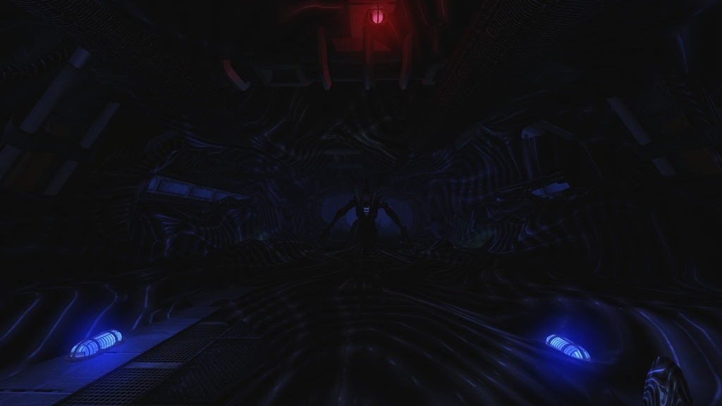[/spoiler]

Bug Hunt ~ *HaTeMe\**

KF-BugHunt-v3.rom

Workshop - [steamcommunity.com/sharedfiles/filedetails/?id=126283862](http://steamcommunity.com/sharedfiles/filedetails/?id=126283862)

D/L - [mediafire.com/download/t4d6j06jde4x893/KF-BugHunt-v3.zip](http://www.mediafire.com/download/t4d6j06jde4x893/KF-BugHunt-v3.zip) [spoiler]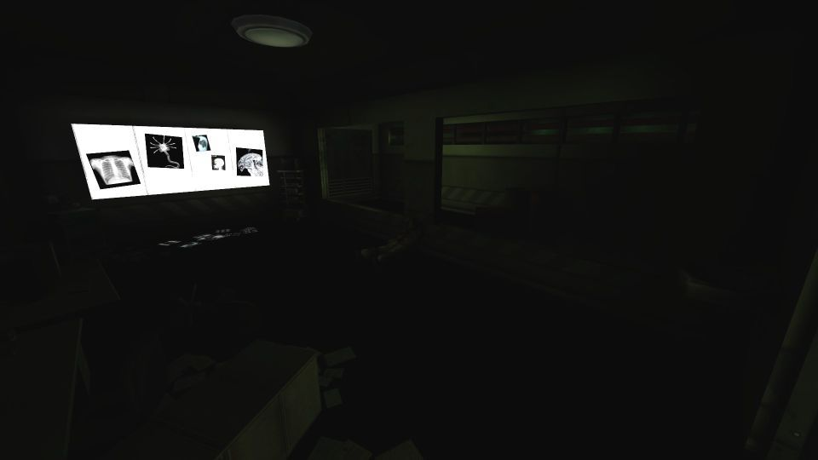[/spoiler]

Starship ~ *ReiN\**

KF-A-Starship.rom

Workshop - [steamcommunity.com/sharedfiles/filedetails/?id=143952091](http://steamcommunity.com/sharedfiles/filedetails/?id=143952091)

D/L - [mediafire.com/download/2aq6gi579m2pvd9/KF-A-Starship.zip](http://www.mediafire.com/download/2aq6gi579m2pvd9/KF-A-Starship.zip) [spoiler]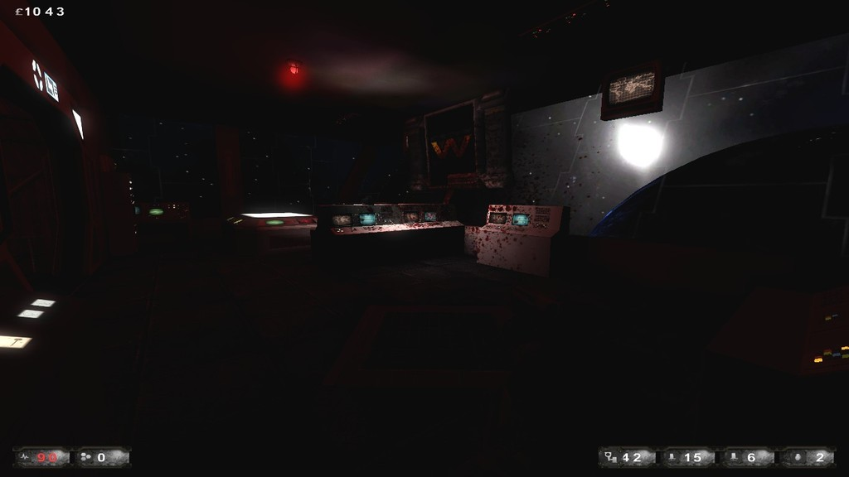[/spoiler]

Hadleys Hope ~ *ReiN\**

KF-A-HadleysHope-beta-1-2.rom

Workshop - [steamcommunity.com/sharedfiles/filedetails/?id=169211588](http://steamcommunity.com/sharedfiles/filedetails/?id=169211588)

D/L - [mediafire.com/download/ofeq45605tpp5qh/KF-A-HadleysHope-beta-1-2.zip](http://www.mediafire.com/download/ofeq45605tpp5qh/KF-A-HadleysHope-beta-1-2.zip) [spoiler]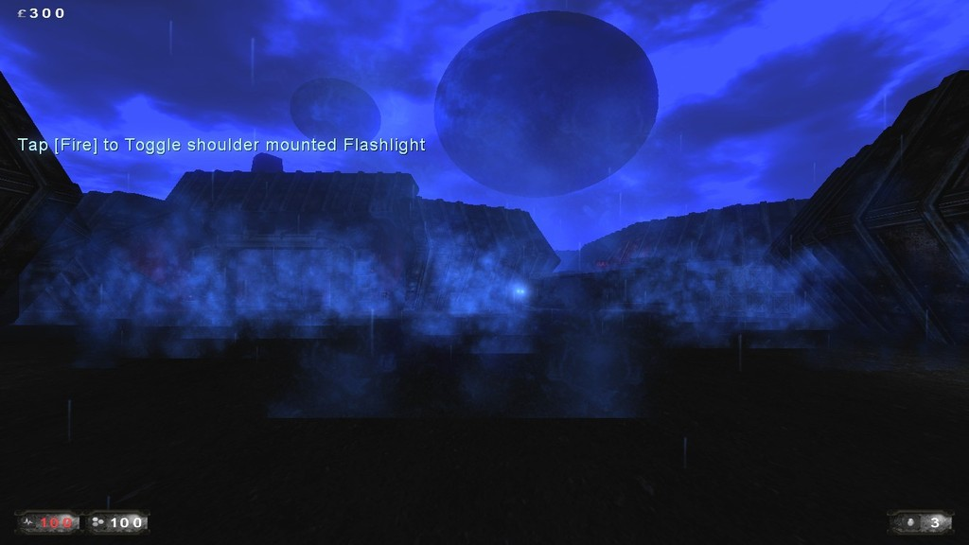[/spoiler]

Outpost ~ *ReiN\**

KF-A-Outpost.rom

Workshop - [steamcommunity.com/sharedfiles/filedetails/?id=143430016](http://steamcommunity.com/sharedfiles/filedetails/?id=143430016)

D/L - [mediafire.com/download/4b8md74wmo752qa/KF-A-Outpost.zip](http://www.mediafire.com/download/4b8md74wmo752qa/KF-A-Outpost.zip) [spoiler]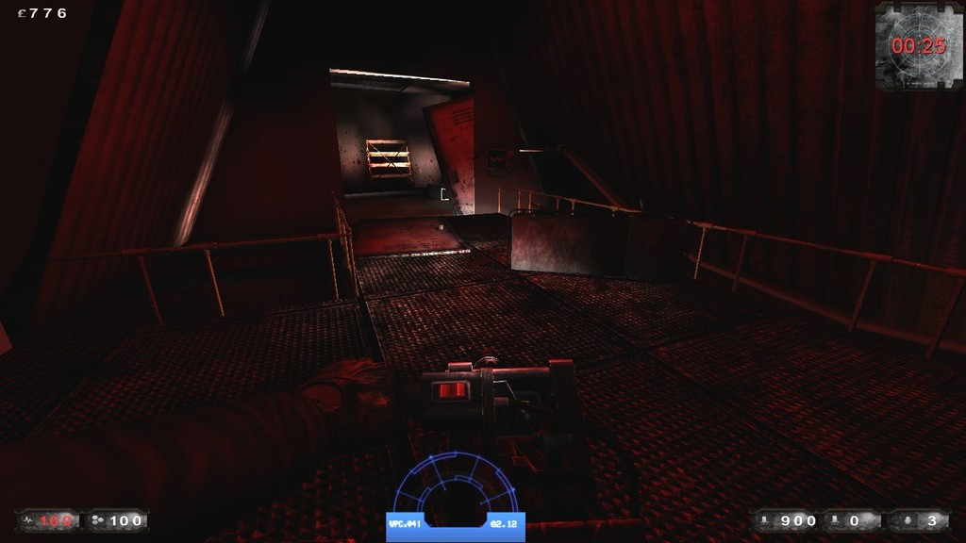[/spoiler]

Icarus ~ *U.N.C.L.E.\**

KF-A-IcaruSVUbeta2.rom

Workshop - [steamcommunity.com/sharedfiles/filedetails/?id=209922729](http://steamcommunity.com/sharedfiles/filedetails/?id=209922729)

D/L - [mediafire.com/download/uxol1a2wbj6xel9/KF-A-IcaruSVUbeta2.zip](http://www.mediafire.com/download/uxol1a2wbj6xel9/KF-A-IcaruSVUbeta2.zip) [spoiler]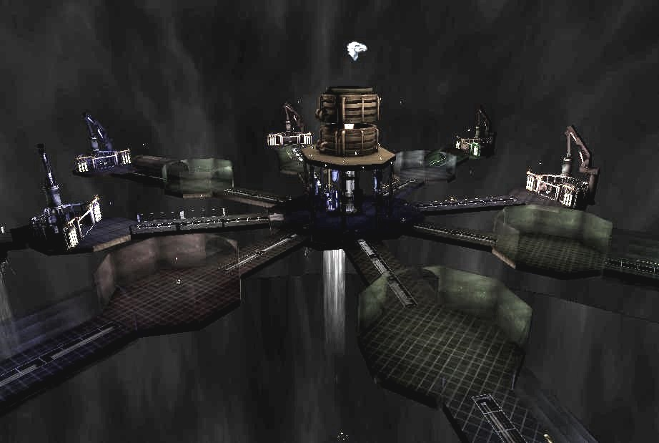[/spoiler]

Alien Base ~ *U.N.C.L.E.\**

KF-AlienWorld_Base-Final4.rom

Workshop - [steamcommunity.com/sharedfiles/filedetails/?id=369726276](http://steamcommunity.com/sharedfiles/filedetails/?id=369726276)

D/L - [mediafire.com/download/bg96e36civllt8p/KF-AlienWorld_Base-Final4.zip](http://www.mediafire.com/download/bg96e36civllt8p/KF-AlienWorld_Base-Final4.zip) [spoiler]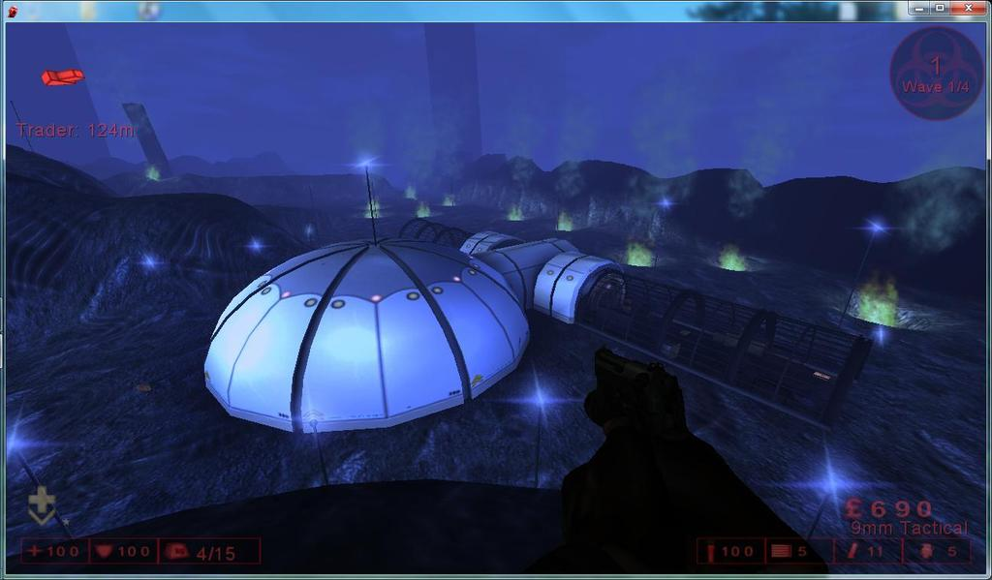[/spoiler]

Hadleys Hallway ~ *WPC Team\**

KF-HadleysHallway.rom

Workshop - [steamcommunity.com/sharedfiles/filedetails/?id=111928275](http://steamcommunity.com/sharedfiles/filedetails/?id=111928275)

D/L - [mediafire.com/download/xjn5awbhb4jzlos/KF-HadleysHallway.zip](http://www.mediafire.com/download/xjn5awbhb4jzlos/KF-HadleysHallway.zip) [spoiler]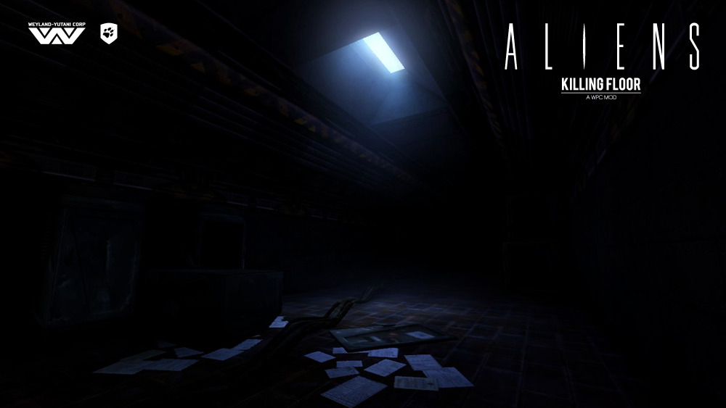[/spoiler]

Atmosphere Processor  ~ *WPC Team\**

KF-AtmosphereProcessor.rom

Workshop - [steamcommunity.com/sharedfiles/filedetails/?id=111922917](http://steamcommunity.com/sharedfiles/filedetails/?id=111922917)

D/L - [mediafire.com/download/wu84h6b5xaip9e5/KF-AtmosphereProcessor.zip](http://www.mediafire.com/download/wu84h6b5xaip9e5/KF-AtmosphereProcessor.zip) [spoiler]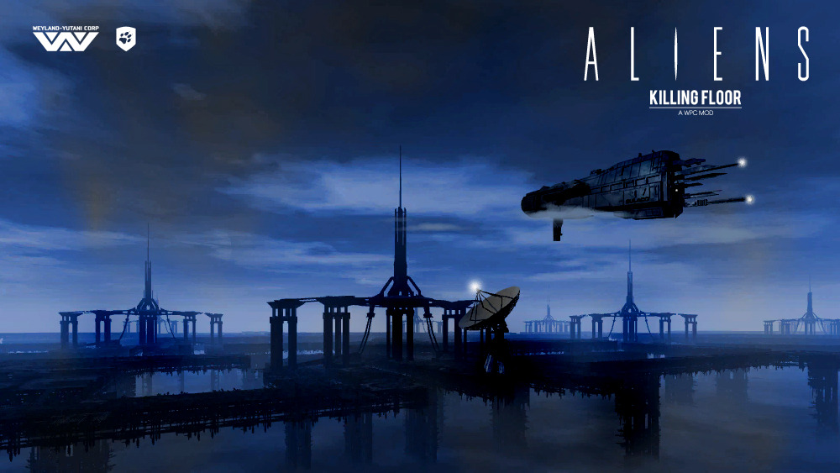[/spoiler][/spoiler]

**Dead Space**

**Заметки**

**-** Мобы кривенькие но их так же весело рубить. Оружие с оригинальной игры прилагается.

**-** Для запуска выделенного сервера

Game=DeadSpaceKFGameType.DeadSpaceKFGameType

[spoiler]Dead Space Killing Floor ~ *WPC\**

Workshop - [steamcommunity.com/workshop/filedetails/?id=98337050](http://steamcommunity.com/workshop/filedetails/?id=98337050)

Форум - [forums.tripwireinteractive.com/showthread.php?t=78150](http://forums.tripwireinteractive.com/showthread.php?t=78150)

ModDb - [moddb.com/mods/kf-dead-space](http://www.moddb.com/mods/kf-dead-space)

Сайт- [mostimpressive.nl/DeadSpace/](http://www.mostimpressive.nl/DeadSpace/)

D/L - [mediafire.com/download/rzf46moc11rk3wk/DeadSpaceV2.zip](http://www.mediafire.com/download/rzf46moc11rk3wk/DeadSpaceV2.zip) [spoiler]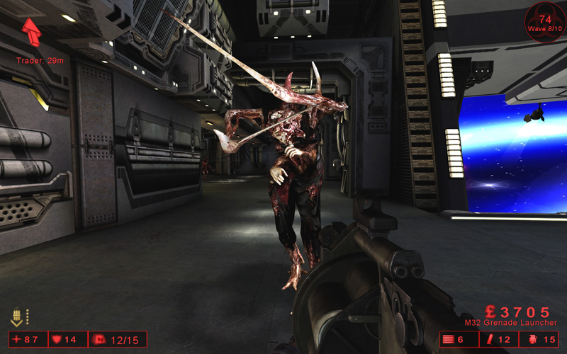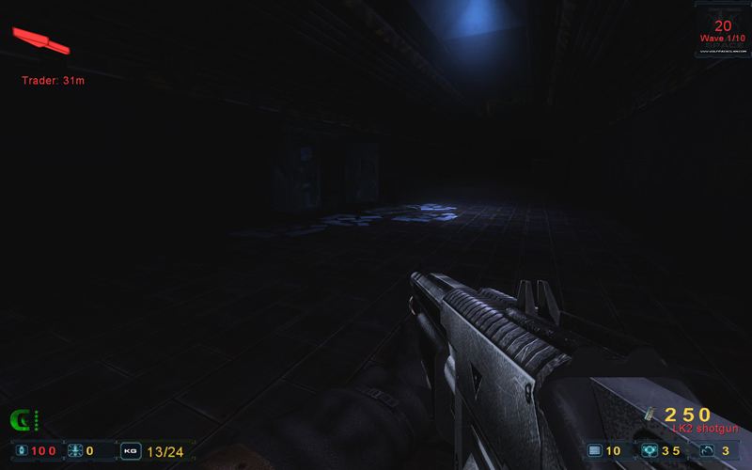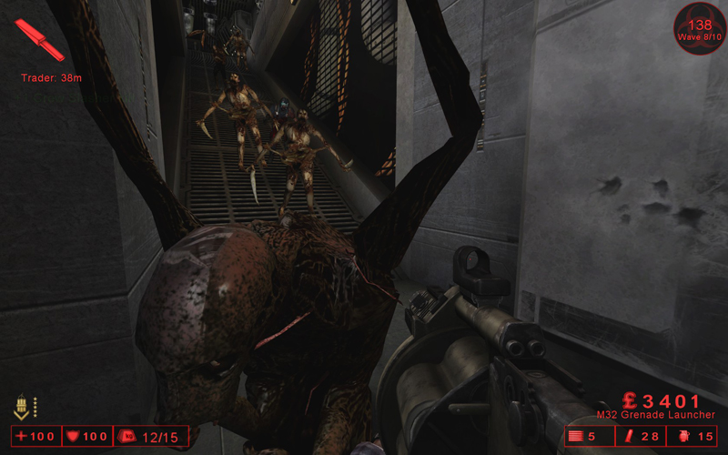[/spoiler][/spoiler]

[Продолжение (Glass House, Gun Game, Trials, Toy Master, TSC) ->](http://killingfloor.ru/forum/index.php?/topic/4219-raznye-game-type-i-karty-k-nim/#entry114381)